Appendix A: 1950s media and government programs motivated American families to prepare

for Communist attacks



*National Space Studies Center*



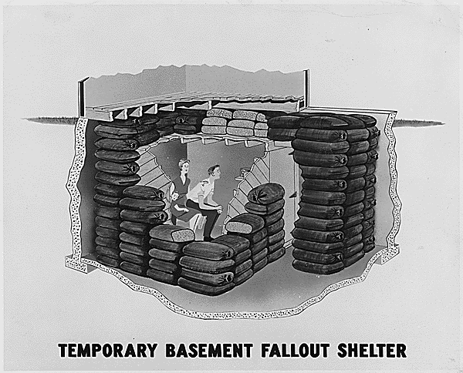

*National Archives*

*Harvard College Library*

Appendix B: Sputnik, the first turning point

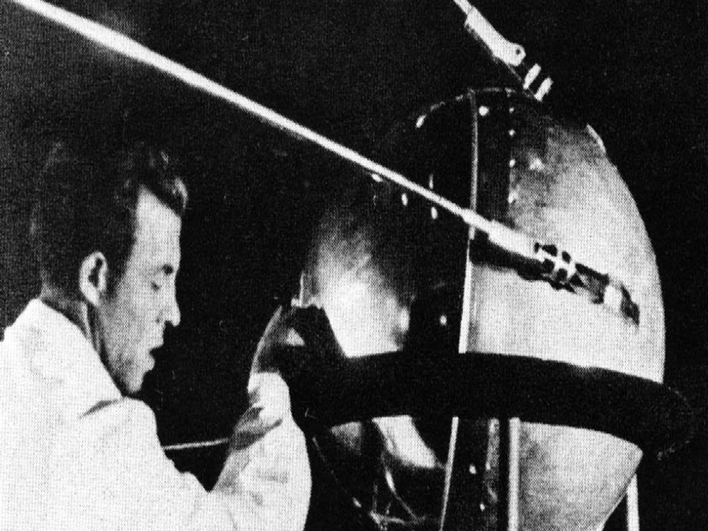

*National Aeronautics and Space Agency (NASA)*

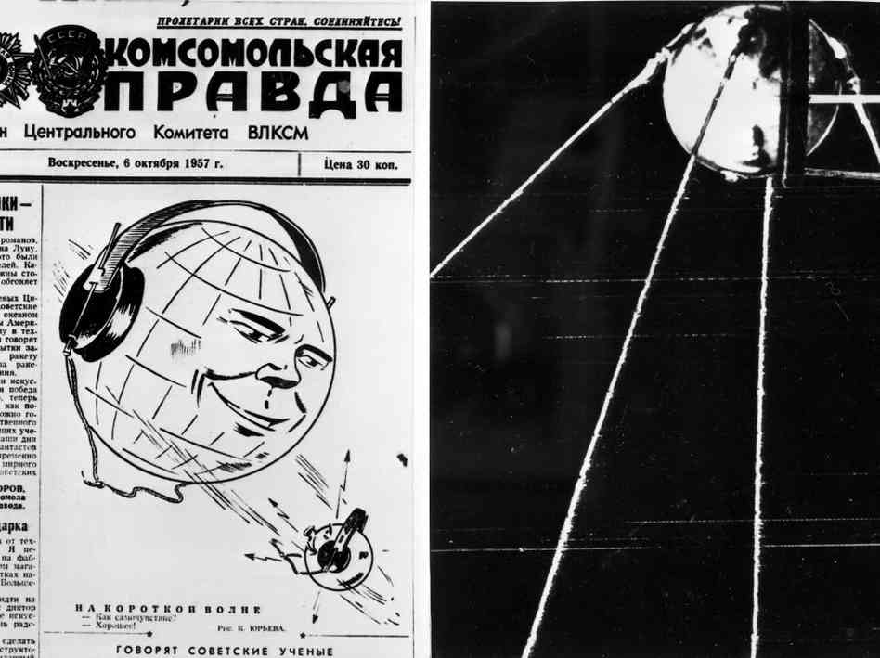

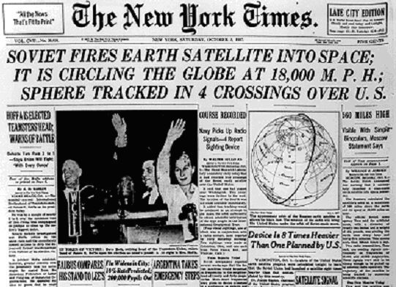

*National Public Radio*

*Massachusetts Institute of Technology*

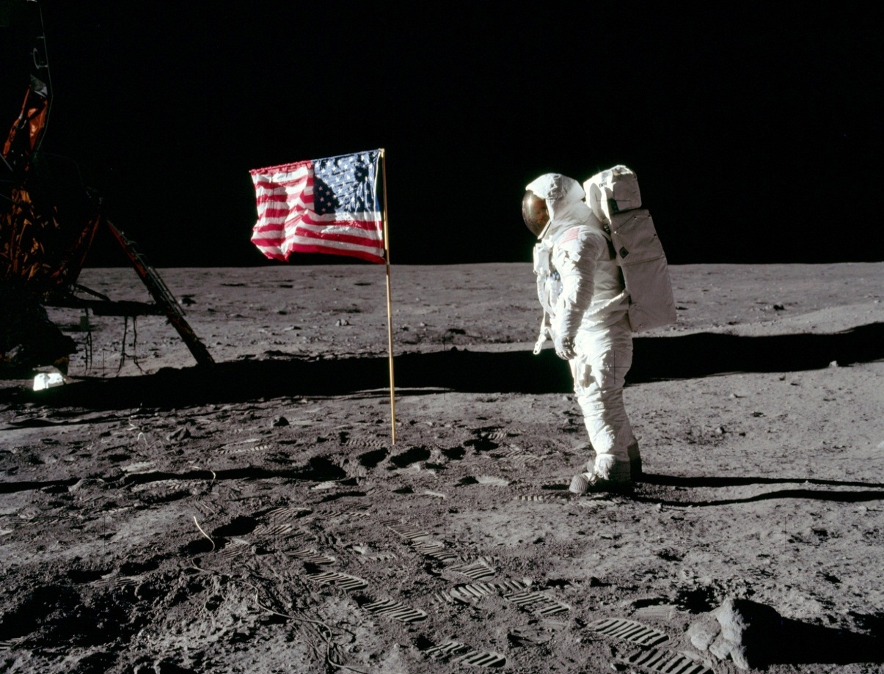Appendix C: Americans land on the moon, ending the space race

***MSNBC***

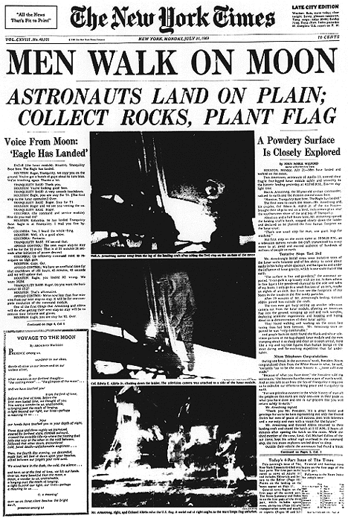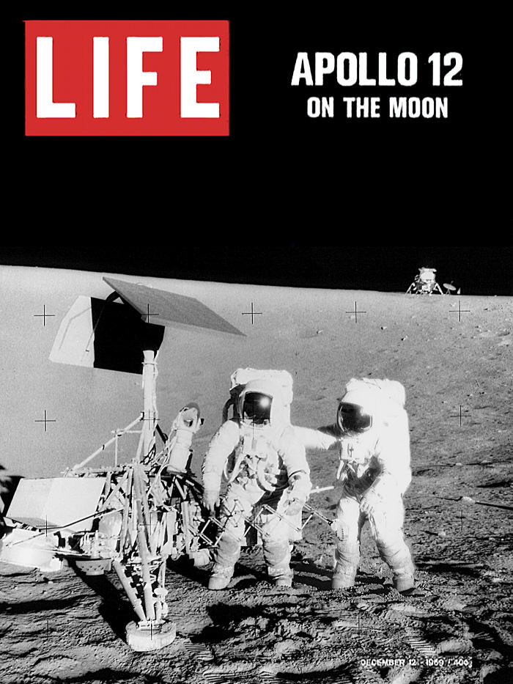

*National Aeronautics and Space Agency (NASA)*

*New York Times*

Appendix D: Apollo-Soyuz handshake in space symbolized a turning point in Soviet/American

relations from competition to cooperation

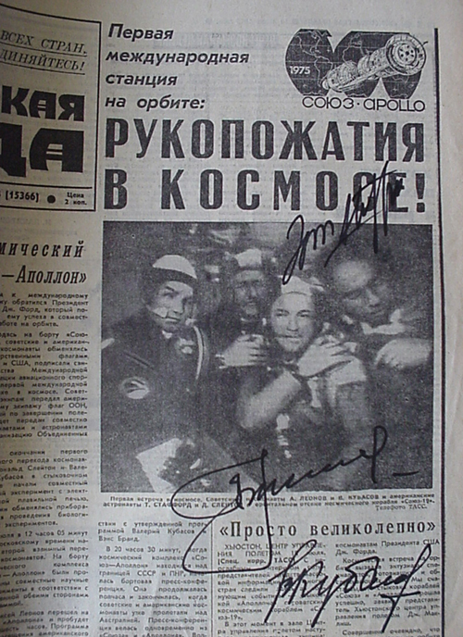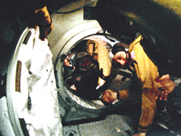

*National Aeronautics and Space Agency (NASA)*

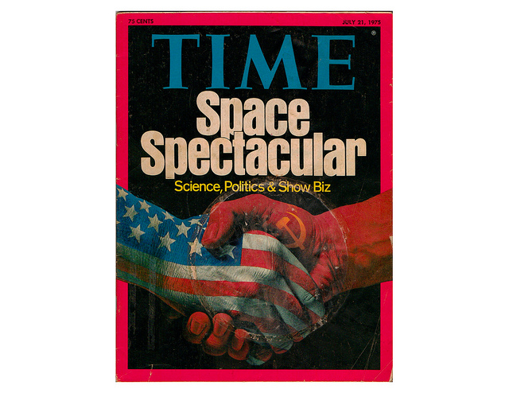

*USSR Airspace*

*Time*