Better Safe Than Sorry?
Internment of Rights in World War II

Helen Hartman

Junior Division

Historical Paper

Paper Length: 2494 words (includes paper and appendix)

War creates situations which Americans would not countenance in times of peace…INS, Department of Justice, 1946 Report
America’s founding fathers defined the rights guaranteed to American citizens in the Bill of Rights, and for over 200 years America has symbolized the “land of the free” both at home and abroad. However, during World War II, the U.S. government established internment camps that usurped the rights of both American citizens and non-citizens of Japanese, German, and Italian descent in the name of national security. Historians have largely documented the loss of Japanese Americans’ rights in War Relocation Authority Camps, which held people of Japanese ancestry who were removed from the West Coast. However, lesser-known camps run by the Immigration and Naturalization Service (INS), like those in Texas, violated the rights of citizens from both America and Latin America. Groups like the Japanese, with resources and political support, have been able to hold the American government responsible for their loss of rights and have received apologies and compensation. German American and German/Italian Latin American internees, however, have not yet received a formal acknowledgement of their internment or redress from the governments that rescinded their individual rights for the sake of national security.
In 1939, World War II erupted in Europe. America did not enter the war, but Congress passed The Alien Registration Act in 1940, requiring all resident aliens over age 14 to register and report to the government any changes in their status. By 1941, peace negotiations deteriorated between America and Japan over Japanese expansion and Japan’s Axis Alliance with Nazi Germany. President Franklin Roosevelt froze all Japanese assets in America, ended oil and raw materials shipments to Japan, and strengthened American military power in the Pacific. The Aliens Division of the Department of Justice compiled lists of aliens to be interned in case war erupted. In early 1941, the Office of Strategic Services also began surveillance of enemy aliens living in Latin America to secure the Western Hemisphere, especially the Panama Canal.
After the Japanese attack on Pearl Harbor, on December 7, 1941, Americans united against the Axis powers of Italy, Germany, and Japan. To reassure the American public that the government was taking responsibility for its safety, President Roosevelt immediately issued Proclamations 2525, 2526, and 2527, reclassifying immigrants who were citizens of Axis nations as enemy aliens, subject to being “apprehended, restrained, secured, and removed.” The Department of Justice arrested 3,000 German, Italian, and Japanese enemy aliens in America to protect “our people, our territory, and our interests.” President Roosevelt also established three wartime organizations to identify and detain people who were considered threats: the Department of State, Special War Problems Division; the Department of Justice Alien Enemy Control Unit; and the War Relocation Authority (WRA).
By December 30, 1941, Attorney General Francis Biddle violated Fourth Amendment rights against unreasonable searches and seizures by authorizing raids on Japanese homes along the West Coast in which one resident was classified as an enemy alien. By early 1942, local policemen throughout America began home “check-ups” and kept dossiers on all registered aliens (Appendix A).
To further protect the nation, President Roosevelt issued Executive Order 9066 in February 1942, assigning responsibility to the Secretary of War for creating areas controlled by the military and for determining whether any person had the right to stay, leave, or enter that area. Although Biddle thought evacuating the Japanese Americans was “unnecessary and unnecessarily cruel,” Lieutenant General John DeWitt, head of the Western Defense Command, used this power to create military zones along America’s western coast. The government forced anyone of Japanese descent to move from those areas into internment camps run by the WRA to prevent any disloyal Japanese from endangering the nation’s safety. Although America had rescinded the rights of non-citizens before World War II, with the Fugitive Slave Acts and the expulsion of Native Americans, the WRA camps established a new precedent in American history. Scattered across western America, WRA camps held approximately 120,000 Japanese internees from the west coast, two-thirds of whom were American citizens who lost their homes,
possessions, and civil rights (Appendix B). Some Japanese, like Fred Korematsu, filed suit against the government, arguing that internment was unconstitutional; however, the Supreme Court upheld the exclusion order, but only in wartime.
WRA camps, however, were not the only kind of internment camps. Camps run by the INS were primarily responsible for protecting against the threat of enemy aliens. INS and FBI representatives attended Alien Enemy Hearing Boards, established in each federal judicial district, to determine whether enemy alien detainees would be released, paroled, interned, or exchanged for American prisoners of war. Although many Japanese Americans, like my family in Texas, were never sent to internment camps, our relatives who wished to avoid internment by leaving the West Coast had to apply for and receive permission from their local boards before they could relocate (Appendix C).
INS camps also held citizens of Latin American nations. Two days after Pearl Harbor, America also assumed responsibility for securing the Western Hemisphere by initiating a program with several Latin American nations to deport Japanese, German, and Italian Latin American citizens who could be exchanged for Americans held by enemy countries. From 1941 to 1945, the American government financed the forced deportation of over 3,000 people from fifteen countries (Appendix D). Without due process of law, internees relinquished their passports in Latin America and traveled as illegal aliens aboard American ships to New Orleans, where they were processed and sent to INS camps.
Although INS camps existed throughout America, Texas had the only INS camp established specifically for families. Additionally, the INS created detention stations in Texas to hold enemy aliens in communities where the number of arrests was too small to justify the creation of an INS camp. Stations at Ft. Bliss in El Paso and Ft. Sam Houston in San Antonio were associated with the Army and operated only during 1942. Civilian internees moved from these detention stations to INS camps the following year to make room for prisoners of war. Lacking time to build new facilities, the INS sought existing locations, and on April 21, 1942, Kenedy camp opened at an old World War I Army training facility. For two years, Kenedy held males and teenage boys from all three enemy nations before converting to a prisoner of war camp. Many, angry that they had been imprisoned without charges, volunteered for repatriation. Seagoville, a former women’s prison, also became a Texas INS facility, holding, at its peak, 650 couples without children and also women enemy aliens.
The INS camp in Crystal City, Texas, was unique. The INS opened Crystal City in December 1942, initially planning to intern only Japanese enemy aliens and their American families who volunteered to join them. The INS realized that when they removed enemy aliens from their families, those families lost their primary breadwinners. Spouses and children, who were American or Latin American citizens, became destitute unless they voluntarily entered the camp and kept the family together. Since family members “volunteered” to be interned, the government did not consider their internment as a violation of rights. Crystal City soon housed multiple nationalities of enemy aliens and their families, including Germans and Italians, both American and Latin American. As the first INS venture in the internment of family groups, no precedent existed for its operation.
Internees could go wherever they wished inside the camp, but to comply with Third Geneva Convention requirements, Crystal City officials had to provide separate schools, recreational centers, and living quarters for German/Italian and Japanese prisoners (Appendix E). Employees could not force internees to perform manual labor, but volunteers could earn up to four dollars per week in camp scrip (Appendix F). A 12' fence, six guard towers, and flood lights surrounded the camp, and a small police force patrolled the camp. Guards searched incoming and outgoing vehicles at the gate. Officials kept records on every internee, conducted daily head counts, censored letters, and maintained surveillance of visitations. By 1945, Crystal City held over 3,400 detainees, the largest camp of its kind in the United States. To accommodate the large, diverse population, camp officials constructed additional temporary buildings, called Victory Huts (Appendix G).
During Crystal City’s operation, over 800 Japanese Latin Americans were included in two prisoner of war exchanges between America and Japan. Swedish ship MS Gripsholm assisted in two massive repatriation movements from Crystal City in February and December 1944 and January 1945. Hundreds of German and Japanese repatriated to countries on the verge of collapse with the promise that America would consider allowing them and their American-born children to return later.
World War II ended on August 14, 1945, and by March of 1946, all of the WRA camps had closed and released their internees. However, Crystal City remained open until 1948, housing mostly Germans still considered dangerous by the government. More than 600 Peruvian Japanese left for Japan because Peru would not allow them to return. Several hundred remained in America, not wanting to go to Japan, unable to return to Peru, and ineligible to apply for American citizenship. Those with jobs and sponsors received permission to remain.
The first effort to provide redress for Japanese Americans occurred in 1948, when President Harry Truman urged Congress to enact the Japanese American Claims Act to compensate Japanese Americans for their losses due to wartime removal and incarceration in WRA camps. Japanese Americans viewed the Act as an important symbol of progress, even though most claimants received much less than they requested; of the $131 million in claims, Congress awarded only $38 million. President Gerald Ford issued Proclamation 4417 in 1976, rescinding Roosevelt’s Executive Order 9066 to prevent future violations of rights. Additionally, the Japanese American Citizens League called for an apology and reparations of $25,000 for each incarcerated individual. Though unanswered, their call set in motion the creation of the National Committee for Redress. To investigate the internment of Japanese Americans during World War II, President Jimmy Carter established the Commission on the Wartime Relocation and Internment of Civilians (CWRIC) in 1980. Public hearings began in Washington, D.C. and other parts of the United States on July 14, 1981. Over 750 Japanese American testimonies convinced the commission that internment of Japanese Americans was unjustified and unconstitutional, which lead to Personal Justice Denied, a report that became a turning point in the redress movement.
By June 16, 1983, the CWRIC issued formal recommendations to Congress calling for:
- $20,000 to each living person who had been interned,
- a formal Congressional apology,
- a research and public education fund to prevent similar events,
- pardons for Japanese Americans who resisted wartime restraints,
- and restoration of entitlements.
President Ronald Reagan signed the Civil Liberties Act into law on August 10, 1988, authorizing the Justice Department’s Office of Redress Administration to administer an apology and allocate $1.25 billion dollars to educate the public about Japanese American internment. To former internee May Tanihara, “the living conditions that many us of had to live through” must be exposed. In addition, payments of $20,000 went to each living former internee over the next ten years (Appendix H). Ray Tanihara, another Japanese internee, received reparation but still feels that money in “no way” compensated for his loss of rights.
Although the Civil Liberties Act addressed the grievances of the Japanese who had been interned under the WRA, many of whom were American citizens, the Act did nothing for German and Italian American citizens or the Japanese, German, and Italian Latin American internees who had been classified as enemy aliens and held in Texas or in other INS camps. In 1996, five Japanese Latin Americans filed a civil suit for redress on behalf of all Japanese Latin American internees. Settlement of this case in 1998 provided each claimant an apology and $5,000, as long as funds remained available. Since their funds were tied to the original Civil Liberties Act, which had distributed all but eleven million dollars of its funds, claimants had a limited amount of redress funds available to them. They also had less than a year remaining before the Act expired.
In 2000, Congress passed the Wartime Violation of Italian American Civil Liberties Act, calling for a report “detailing injustices suffered by Italian Americans during World War II.” Issued in November 2001, A Review of the Restrictions on Persons of Italian Ancestry during World War II acknowledged that the government had violated the rights of Italians living in America by interning them during World War II. To pursue redress for other forgotten internees, The Wartime Treatment Study Act was introduced to the Senate on August 3, 2001, to create an independent commission responsible for reviewing government policies that affected European enemy ethnic groups during World War II both in America and in Latin America. Although the bill was reintroduced in March 2009, no action has yet been taken.
Japan’s attack on Pearl Harbor plunged America into World War II and united Americans against their Axis enemies, both at home and abroad. Amid the crisis, the United States government implemented a better safe than sorry policy, interning Japanese, Italian, and German Americans and Latin Americans in the name of wartime responsibility. The American press and most American citizens condoned the process, preferring to intern anyone considered a potential threat to America to omit any possibility that they might assist the enemy. However, this government policy not only violated the Constitutional rights guaranteed to American citizens but also violated international human rights by bringing Latin American citizens into America to barter them in prisoner exchanges.
Attempting to hold the government responsible for these individuals’ loss of rights has been a lengthy process. For vocal internee groups with financial resources and political backing, the American government has accepted responsibility by acknowledging its actions and, in some cases, by providing monetary redress and apologies. However, German American and German/Italian Latin American internees have not received acknowledgement or compensation to date, though German Americans are in the process of pursuing redress. Small groups who have opted to remain silent or lack the resources to pursue compensation may never receive redress. For Guenther Greis, a German American who was interned at Crystal City as a child, the lesson is clear: “All Americans must know the dreadful consequences of liberty lost, so they can ensure that it does not happen again.” Testimonies like his provide Americans with valuable insight for the future. Only by balancing government responsibility and the rights of all individuals will America epitomize “the land of the free.”

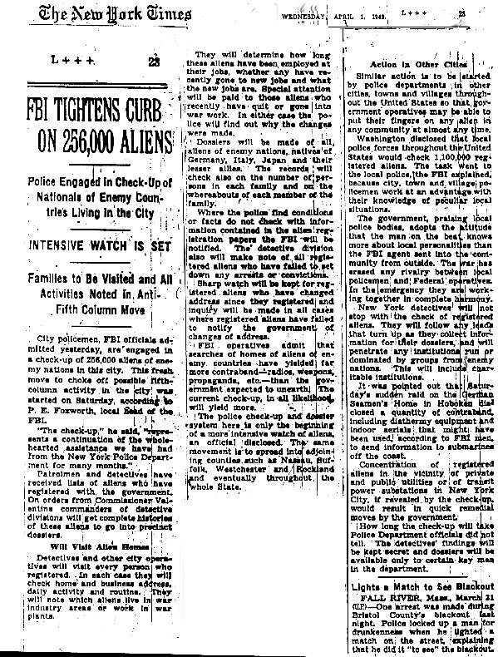
Appendix A: April 1, 1942 article showing America’s search for enemy alien spies and Axis sympathizers
Appendix B: Rohwer, Arkansas Relocation Camp for Japanese-American detainees
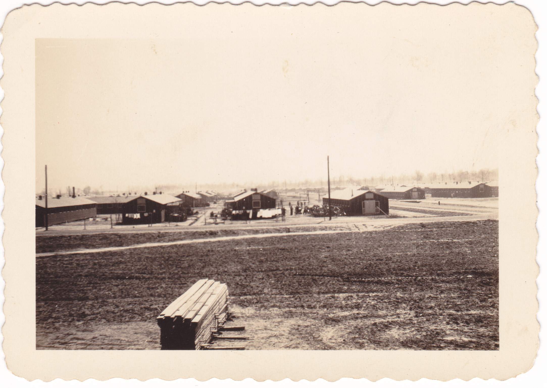

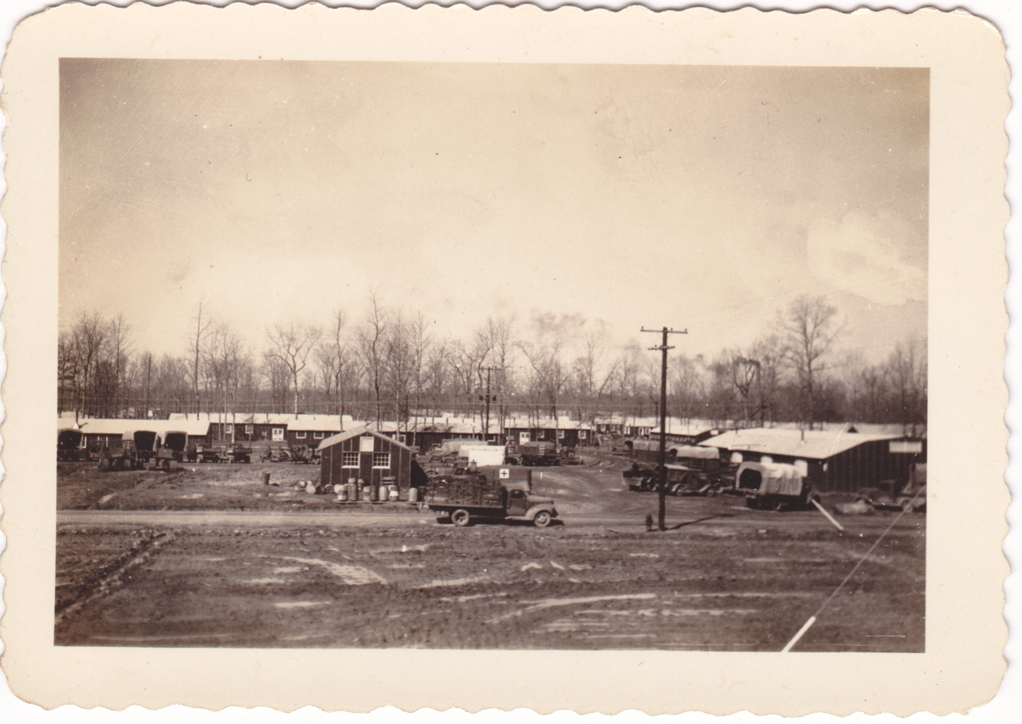

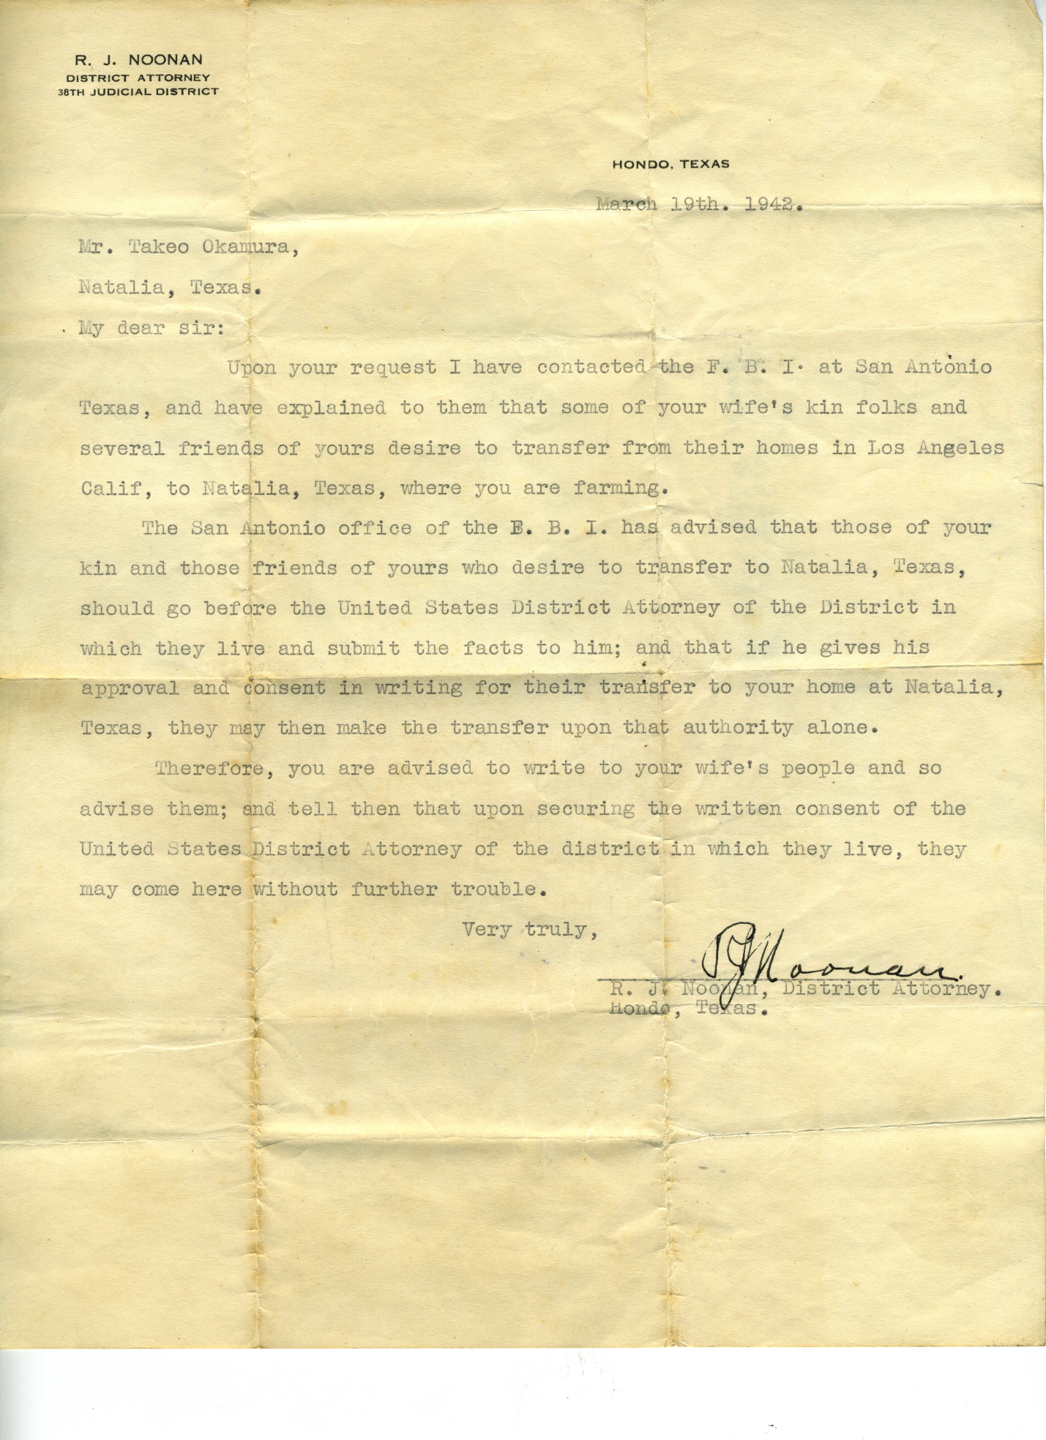
Appendix C: March 19, 1942 letter documenting Alien Enemy Hearing Board procedures
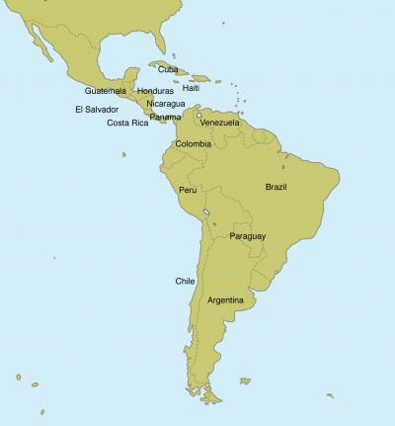
Appendix D: Latin American Nations participating in enemy alien exchanges
Texas Historical Commission

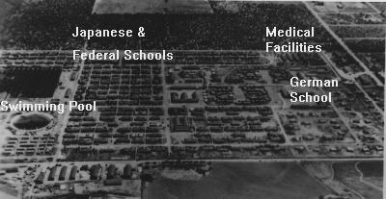
Appendix E: Crystal City’s segregated facilities
Freedom of Information Times
Appendix F: Camp scrip
Texas Historical Commission

Appendix G: Crystal City’s Victory Huts
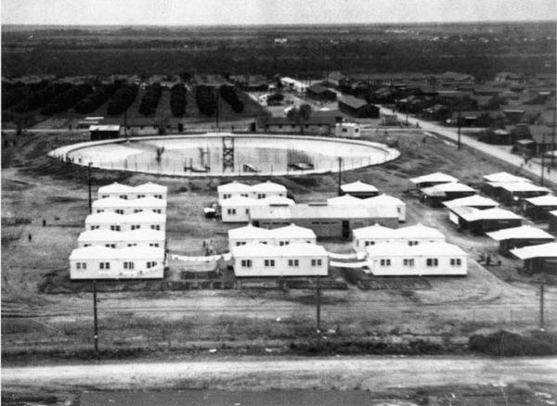
Institute of Texan Cultures
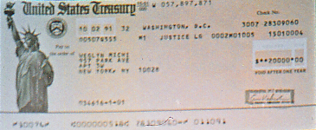
Appendix H: Redress check for Michi Weglyn, former internee, 1991

Weglyn

Annotated Bibliography

Primary Sources

Unpublished Documents

“Camp Barracks.” Photo. Rohwer Internment Camp, Arkansas. Circa 1942. Personal photo held by author.

This is a photo of Rohwer Internment Camp in Arkansas where my relatives were interned during World War II. They arrived September 27, 1942. I used this photo in my appendix to show what one relocation camp looked like when my family arrived.

“Rohwer Camp Buildings.” Photo. Rohwer Internment Camp, Arkansas. Circa 1942. Personal photo held by author.

This is a photo of the camp where my relatives lived during their internment. My great-great-grandfather, Kitaro Hayashi, and my great-great-aunt, Kiyoko Hayashi, were released on June 19, 1943, and moved to Texas to live with my great-grandparents, Kitaro Hayashi’s daughter, Yoneko, and her husband, Takeo. My great-great uncle, Masao Hayashi, his wife, Asano, and their children left Rohwer on September 14, 1943, and were transferred to Tule Lake Camp. Later they returned to Japan. I used this photo in my appendix to show what the WRA internment camps looked like.

R. J. Noonan, letter to Takeo Okamura. Mar. 19, 1942. Personal letter held by author.

This is a letter sent to my great-grandfather, Takeo Okamura, from R. J. Noonan, who was the District Attorney in Hondo, Texas, in early 1942. My great-grandfather had written to Noonan to request permission for his wife’s family to move from California to Natalia, Texas, rather than be interned. This letter shows the process that the Japanese people who were being relocated had to go through to move from the jurisdiction to another. I used this photo in my appendix to show one of the duties of the Alien Enemy Hearing boards.

Interviews

Tanihara, May. [maytanihara@comcast.net] Email interview by author. March 14, 2014.

May Tanihara is a Japanese American who were interned during WWII. She was living in California before the war and interned in a camp run by the War Relocation Authority in Tule Lake, California. She first came to the camp when she was 7, and remained there for the next four years. By interviewing her, I can better understand how she feels and why she strongly believes the public should be better educated about this. I used a quote from her in my paper to show how she feels about informing more people about the internment of Japanese Americans during WWII.

Tanihara, Ray. [maytanihara@comcast.net] Email interview by author. March 14, 2014.

Ray was interned in Jerome, Arkansas, when he was 13 years old. He explained that he was extremely angry about being interned, but he had no choice. Although he received $20,000 in reparations, he explained that the money in no way compensated for the misery that internment caused. He moved back to California, where he met his wife May, who had been in a different camp.

Fuhr, Eberhard E. “My Internment by the US Government.” Jan. 24, 2001. Freedom of
Information Times.http://www.foitimes.com/internment/Fuhr.htm (accessed Sept. 10, 2013).

This is a transcript of personal history testimony given by Eberhard Fuhr, who was interned in the Crystal City, Texas, camp. He explained the process of how his parents were arrested and interned while he and his brother remained on their own. Later, when they were also arrested, the family lost all of their possessions, their dignity, and their home. He gave a good description of the Crystal City camp, which I used to explain the conditions prisoners in the camp faced. He also said that after the war ended, everyone expected to be released, but that did not happen. He was eventually released in September 1947.

Pinnow, Otto Karl Johann. “The Trials and Tribulations of Otto Karl Johann Pinnow.”
Interview by Otla Pinnow. Freedom of Information Times. http://foitimes.com/Pinnow.pdf (accessed Sept. 10, 2013).

This is a transcript by Otla Pinnow of her father’s experience during World War II in Germany, Peru, and Kenedy Internment Camp in Texas. Because he was not a Nazi, Pinnow was under suspicion in Germany and escaped to Peru just as the Gestapo came to pick him up; he worked for a time in Peru before that government agreed to his arrest and deportation to Texas as an enemy alien to live in the Kenedy Internment Camp. He was traumatized by his treatment and, ironically, went back to Germany rather than stay in either of the two countries who arrested and imprisoned him without charges. Since he had been a prisoner in America, he was not considered a threat when he returned to Germany. This interview helped me understand how violations of individual rights impacted some of the internees.

Schneider, Gertrude Anna. Interview by Vilma Schneider Ralston. March 1983. German
American Internee Coalition. http://www.gaic.info/real_schneider.html (accessed Sept. 10, 2013).

In this interview, Gertrude Schneider describes to her daughter her experience as an
internee in the Seagoville, Texas, internment center. Her husband and their children were American citizens, but since she was not, she was separated from them from December 1941 until her release in January 1943. Even though her husband had become an American citizen, he had been born in Germany, and because she was in prison as an “enemy alien” he was persecuted and lost several jobs. They lost their home and he had to move in with other family members to survive. This interview helped me understand how the families of internees were treated after they were arrested.

Testimonial

Greis, Guenther. “The Greis Story – Parents Interned While Sons Served.” Freedom of
Information Times. May 28, 2001. http://www.foitimes.com/internment/Greis.htm. (accessed Mar. 8, 2014.)

This is a testimonial written by Guenther Greis about his experiences as an internee in Crystal City. He explains that life in Crystal City was organized and allowed him to stay with his family. In other camps, they had been segregated. I used a quote from him in my conclusion to show that Americans can learn from the past to prevent future violations of civil rights.

Letters and Telegraphs

Letter from Ivan Williams, Officer in Charge, Alien Internment Camp, Kenedy, TX, to N. F.
Kelly, Assistant Commissioner for Alien Control, Philadelphia, PA. Dec. 23, 1943. National Archives. Department of State, Special War Problems Division. Record Group 59, Document 52.

This letter to the Assistant Commissioner for Alien Control explains that the German detainees at the INS camp in Kenedy, TX, had been put into categories to determine priorities for sending them back to Germany. I learned how the detainees were ranked for repatriation and prisoner exchanges.

Letter from R. F. Fitch, Chief Special Agent, to Mr. James F. Delaney, District Supervisor,
Immigration and Naturalization Service. Dec. 23, 1944. National Archives. Department of State, Special War Problems Division. Record Group 59, Document 75.

In this letter, Fitch explains that prisoners departing on the MS Gripsholm who are to be
exchanged for American Prisoners of War in Algiers can take only three suitcases with them. The rest will be shipped. Men 18 - 60 have to sign oath forms that they will not “bear arms for the duration of the present war.” This letter provided information about the procedure for sending enemy aliens for exchange.

Telegraph from State Department WA to All Agents in Charge of Movements, State Department
NY. January 1945. Declassified E. O. 12356, Sec. 3.3. NND 867200 by RN, June 21, 1990. National Archives. Department of State, Special War Problems Division. Record Group 59, Document 81.

This telegraph message explains that all agents in charge of German repatriates must hold
the prisoners under strict guard at all times and make sure that they have no opportunity to pass or receive information either verbal or written. It also warns that they need to be particularly careful in Jersey City. I used this information to learn about how the prisoner exchanges were handled.

Newspaper Articles

“FBI Tightens Curb on 256,000 Aliens: Police Engaged in Check-Up of Nationals of Enemy
Countries Living in the City.” New York Times. April 1, 1942. http://www.foitimes.com/internment/NYTimes.jpg (accessed Jan. 6, 2014).

This article states that police in New York City and all major cities across America are
conducting check-ups by visiting the homes of all registered aliens. They are also keeping secret dossiers on everyone living in the households to determine their threat level. I used a copy of this article in my appendix to show that all major America cities, not just those on the west coast, were participating in the round up of potential enemy aliens living in America.

Photos

“Victory Huts.” University of Texas San Antonio, Institute of Texan Cultures. http://www.thc.
state.tx.us/preserve/projects-and-programs/military-history/texas-world-war-ii/world-war-ii-japanese-american-2 (accessed Jan. 20, 2014).

This is a photo of the Victory Huts erected at Crystal City internment camp. I used this photo in my appendix to show the buildings that camp officials erected to be used whenever there was not enough housing at the INS camps.

Government Documents

Japanese Latin Americans to Receive Compensation for Internment During World War II.
Department of Justice. Press Release. June 12, 1998. http://www.justice.gov/opa/pr/1998/June/276.htm.html (accessed Jan. 4. 2014).

This document is a copy of the press release issued by the Department of Justice about the settlement of a court case filed by Japanese Latin Americans who wanted redress for all Japanese Latin Americans interned. I learned that Japanese Latin Americans received an apology and $5,000 each, using the remaining funds from the Civil Liberties Act. I used this information to show that only Japanese Americans and Japanese Latin Americans had received any form of redress at that time.

"Justice Department Review of Restrictions on Persons of Italian Ancestry during World War II
Submitted to Congress." Department of Justice, Nov. 8, 2001. http://www.justice.gov/ opa/pr/2001/November/01_ ins_596.htm (accessed Mar. 14, 2014).

This document is a press release published by the Justice Department stating that the
report on the treatment of Italian American before and during World War II had been given to Congress, meeting the provisions of HR 2442, the Wartime Violation of Italian American Civil Liberties Act. I used this information to show that Italian Americans have sought and received documentation for civil rights violations during World War II.
Munson, Curtis B., Japanese on the West Coast. (Nov. 1941), 14.http://home.comcast.net/ ~eo9066/1941/41-11/Munson.html (accessed Nov. 5, 2013).

This is a copy of the Munson Report stating that although there was no imminent threat from the Japanese on the west coast, Munson believed that it would only take a few disloyal Japanese Americans to plan attacks against the U.S. This report helped me understand that many Japanese Americans were placed in internment camps even though most Japanese were loyal Americans. This report helped me create my title of Better Safe Than Sorry.

O’Rourke, Joseph to W. F. Kelly, Assistant Commissioner for Alien Control Office. Historical
Narrative of the Crystal City Internment Camp. September 19, 1945. Record Group 85, Immigration and Naturalization Service. Crystal City Internment Camp, File 217/021.

This is an official Immigration and Naturalization Service report describing the creation of the Crystal City camp and the duties of the employees there. This document was very helpful because it gave a complete overview of the camp from the perspective of the INS, including the organization and administration of the camp, the internee population and their organization, and camp life and activities. I used information from this report to explain when the camp started, how it was designed, and what the detainees faced during their internment.

“Personal Justice Denied, Part 2: Recommendations.” Report of the Commission on Wartime
Relocation and Internment of Civilians. July 5, 1983. National Archives Library.http://www.archives.gov/research/japanese-americans/justice-denied/part-2-recommendations.pdf (accessed Jan. 2, 2014).

This is a report issued by the Commission on Wartime Relocation and Internment of
Civilians stating their recommendations. I used information from this section to summarize the recommendations made to compensate Japanese internment camp detainees for their losses.

Roosevelt, Franklin D. "Address to Congress Requesting a Declaration of War with Japan,"
December 8, 1941. Online by Gerhard Peters and John T. Woolley, The American Presidency Project. http://www.presidency.ucsb.edu/ws/?pid=16053(accessed Nov. 15, 2013).

This is Franklin Roosevelt’s declaration of war on December 8, 1941. I used a quote from Roosevelt’s speech to show how he defined enemies of America once war was declared.

Roosevelt, Franklin D. Executive Order 9066, Authorizing the Secretary of War to Prescribe Military Areas. February 2, 1942. The U.S. National Archives and Records Administration, n.d. Web. http://research.archives.gov/description/5730250 (accessed November 2, 2013).

This document, written by President Roosevelt, gave the Secretary of War and his subordinates the power to designate military zones and could determine whether any person could leave, stay or enter those areas. This gave the Secretary of War very broad powers; he could force any person, not just one of Japanese descent, to leave the area. I used this order to show the first step towards the internment of Japanese Americans on the West Coast.

- - - -. Executive Order 9102 Establishing the War Relocation Authority. March 18, 1942. Online by Gerhard Peters and John T. Woolley, The American Presidency Project. http://www.presidency.ucsb.edu/ws/?pid=16239 (accessed Nov. 16, 2013).

This is the order that established the War Relocation Authority, the agency that was
responsible for the evacuation and internment of America citizens and permanent aliens, mainly on the west coast after the bombing of Pearl Harbor. Information in this document helped me understand how the responsibilities of this agency were different from the responsibilities that other agencies had. I used it to describe the difference between the well-known Japanese internment camps and the less known camps in Texas that were run by the Justice Department and Department of Immigration and Naturalization.

- - - -. Presidential Proclamation 2525, Enemy Aliens – Japanese. Dec. 7, 1941. http://www-rohan.sdsu.edu/dept/polsciwb/brianl/docs/1941PRESIDENTIALPROCLAMATIONaliensjapanese.pdf (accessed Sept. 10, 2013).

This document is a copy of Proclamation 2525 declaring that all Japanese natives, citizens,
and subjects over the age of 14 are eligible for arrest and removal because of the declaration of war with Japan. I used this to show President Roosevelt’s reaction to the bombing of Pearl Harbor. It laid the groundwork for the internment camps later in 1942.

- - - -. Presidential Proclamation 2526, Enemy Aliens – German. Dec. 7, 1941. http://foitimes.com/internment/Proc2526.html (accessed Sept. 10, 2013).

This document is Proclamation 2526 declaring that all German natives, citizens, and
subjects over the age of 14 are eligible for arrest and removal because of the declaration of war with Germany. I used this to show President Roosevelt’s proclamation that was intended to protect Americans from German spies or sympathizers living in the United States.

- - - -. Presidential Proclamation 2527, Enemy Aliens – Italian. Dec. 7, 1941. http://foitimes.com/internment/Proc2527.html (accessed Sept. 10, 2013).

This document is a copy of Proclamation 2527 declaring that all Italian natives, citizens,
and subjects over the age of 14 are eligible for arrest and removal because of the declaration of war with Axis powers. I used this to show that any Italians in the United States at the time World War II began were subject to government investigation. Later, in 1941, some would be arrested and interned.

Wartime Violation of Italian American Civil Liberties Act. [H.R. 2442]. 106th Congress, 2nd
Session. Nov. 7, 2000. Pub. L. 106-451. U. S. Department of Homeland Security, U. S. Citizenship and Immigration Service. http://www.uscis.gov/iframe/ilink/docView/ PUBLAW/HTML/PUBLAW/0-0-0-23651.html (accessed Feb. 28, 2014).

This Act was signed into law by President Bill Clinton to document the history of
wartime restrictions on Italian Americans living in the United States. The Act states that this history “has been largely absent from the American history books” and that the purpose of the Act is to reveal the “history and the plight of an immigrant people living in the United States who endured oppression during World War II.” I used this information to show that the U. S. Government acknowledged its violation of Italian Americans rights during World War II.

Books

Biddle, Francis. In Brief Authority. Garden City, NY: Doubleday and Company, Inc., 1962.

Francis Biddle was the U. S. Attorney General under President Franklin Roosevelt. He wrote this book in 1962 to reflect on his life. I used information that explained his role in the internment of Japanese during World War II. I used a quote from his book to show that he felt that internment was unusually cruel and yet he was in charge of enforcing Roosevelt’s Executive Order. This book helped me understand that some U. S. authorities disagreed with the government’s decision to intern American citizens.

Department of State. Peace and War: United States Foreign Policy 1931 – 1941. Washington,
D.C: U. S. Government Printing Office, 1942.

This publication includes State Department documents dealing with foreign policy from 1930 – 1941. It has information about President Roosevelt’s Executive order on July 26, 1941 that froze Japanese assets in the United States. I used this information to show that Japanese peace talks were not working and that American officials suspected an attack on America.

Weglyn, Michi Nishiura. Years of Infamy: The Untold Story of America’s Concentration Camps,
updated edition. Seattle: University of Washington Press, 1996.

At the age of 16, Michi Weglyn became a prisoner in the Gila River Relocation Center in Arizona. When war broke out in 1942, her family was forcibly removed from their home in Brentwood, California, by the War Relocation Authority and traveled to Arizona, where they spent the next three years in Block 66, Barrack 12, with 13,000 other inmates. In the 1960s, she used primary documents from the National Archives, the Franklin Roosevelt Library, and the New York City Library to prove that “incarceration was not related to military necessity, but was racially motivated.” As a result, in 1980, Congress created the Commission on Wartime Relocation and Internment of Civilians to investigate, and their report inspired the Civil Liberties Act of 1988, which provided each victim with $20,000 and a formal apology. I used this book to show how the Civil Liberties Act of 1988 showed that America took responsibility for its actions against the Japanese and gave each internee $20,000 to compensate for the rights that were taken away from them. I also used a copy of her check in my appendix.

Videos

Alien Enemy Detention Facility Crystal City. Prod. The Immigration and Naturalization Service,
Department of Justice, Washington, D.C., 1945. YouTube. http://www.youtube.com/ watch?v=WRfSHgdh2UA (accessed Dec. 17, 2013).

This video is an overview of the Crystal City internment camp from the government’s point of view. The majority of the internees were American citizens who had volunteered to join an enemy alien detainee rather than separate the family. The government had to add around 500 new buildings to the existing facilities to make room for the internees. I learned that mail was examined by German, Spanish and Japanese censors. Most internees used community showers and latrines, although some of the housing had indoor facilities. German and Japanese centers were kept separate. This film showed all of the positive aspects of the Crystal City camp and helped me understand how the government promoted internment to the American people. I used information from this video to explain that the rules of the Third Geneva Convention required that the internees had to be housed in separate facilities.

Japanese American Internment and Redress. American History TV. http://64.70.12.51/History/ Events/Japanese-American-Internment-and-Redress/10737440680-2/ (accessed Jan. 6, 2014).

This video featured people who were part of the Japanese redress movement. Grant
Ujifusa was the Japanese American Citizens League Legislative Strategist from 1985 to 1988 and was responsible for bringing the issue of redress before Congress. Thomas Kean was the former governor of New Jersey from 1983-1990. He was responsible for speaking to President Ronald Reagan and getting him to sign the Civil Liberties Act of 1988. Their conversation helped me understand that President Reagan wanted America to be fiscally responsible and did not want to sign the Act because of the money it would take to compensate the Japanese internees. Thomas Kean was able to convince Reagan to sign the Act by asking him to read the testimonies of the internees. I used this information to explain the enactment of the Civil Liberties Act of 1988.

Secondary Sources

Interviews

McWhorter, William. Interviews by author. Dec. 3, 2013 and Feb. 7, 2014.

William McWhorter is the Military Sites Program and Oral History Program Coordinator for the Texas Historical Commission. One of his major projects has been the historic research and interpretation project on Japanese, German and Italian civilian detainment sites in Texas during World War II. He was able to tell me the differences between the camps in Texas and explained how all of the Texas camps were different from those handled by the War Relocation Authority. He gave me copies of the brochures he created on the camps, arranged for me to tour the camp in Crystal City, and acted as my guide through the camp. I visited all of the remaining sites and buildings in the Crystal City Camp, such as the swimming pool built by one of the internees held there. He also read my paper and offered editing advice. I used information from this interview to explain how the Texas camps were different from other camps and to explain the unique quality of the camp in Crystal City.

Photos

Map of Central and South America. Texas Historical Commission. http://www.thc.state.tx.us/ preserve/projects-and-programs/military-history/texas-world-war-ii/japanese-german-and-italian (accessed Dec. 12, 2013).

This is a map showing the Central and South American countries that participated in the round-up and deportation of German, Italian, and Japanese enemy aliens living in those countries. These detainees were then sent to Crystal City, Texas, and other camps in the United States that held Latin American internees. I used this map in my appendix to show the countries that participated in the program to send Latin American internees to Texas.

Newspaper Articles

Michael Graczyk, “Texas Preserves World War II Internment Camp.” Associated Press Dec. 7,
2010. http://www.nbcnews.com/id/40544739/ns/us_news-life/t/texas#.Us2DGxjnbcs (accessed Sept. 10, 2013).

This article is about the Crystal City, Texas, internment camp. It explained that the camp was segregated because, according to the Geneva Convention, camps holding prisoners of different nationalities had to provide separate quarters for the groups. I used this information to explain why Crystal City had separate facilities for the internees in the camp.

Pamphlets

“Crystal City Family Internment Camp: Enemy Alien Internment in Texas during World War
II.” Austin: Texas Historical Commission, 2011.

William McWhorter of the Texas Historical Commission gave me this pamphlet on the Crystal City Family Internment Camp. It contained a brief history of the camp and included primary source documents from his research. I used information from this pamphlet to discuss how Latin Americans came to the camp; it included a map showing which Latin American countries that most of these internees came from.

“Fort Bliss, Fort Sam Houston, Kenedy, Seagoville, and Crystal City: Enemy Alien Internment in Texas during World War II.” Austin: Texas Historical Commission, 2013.

This pamphlet was also given to me by William McWhorter. It gave me a very good overview of all the Texas camps, and brief summaries of each one. I learned about the Victory Huts that internees had to stay in when there was little space in the camp, and the pamphlet also provided information about the detention stations.

Books

Alonso, Karen. Korematsu v. United States: Japanese-American Internment Camps.
Springfield: Enslow Publishers, Inc., 1998.

This book discusses the Korematsu v. United States court case in which Fred Korematsu sues the government to challenge its right to intern Japanese citizens during World War II. I used information from this book to show that some Japanese citizens questioned the government, but the U. S. Supreme Court ruled that the government did have the right to intern Japanese citizens because America was at war. Later the case was reopened and Korematsu’s conviction was overturned but the court did not alter the constitutionality of the decision.

Daniels, Roger. Prisoners Without Trial: Japanese Americans in World War II. New York:
Hill and Wang, 2004.

In this book, Daniels explains the history behind the prejudice against Japanese immigrants in the United States. Although many of the comments and examples were biased toward the Japanese point of view, it did help me understand how racial prejudice against the Japanese made them targets for internment. This book helped me develop a timeline for the events that occurred before the war and the laws that went into effect after Pearl Harbor was bombed. I used information from this book to describe the events that occurred leading to the Japanese being rounded up and sent to camps around the United States, their treatment once they arrived, and the effects that the camps had on their lives after the war ended.

Donlan, Leni. How Did This Happen Here? Chicago: Raintree, 2008.

This book is part of the American History through Primary Sources Series and explains what happened to Japanese Americans after the attack on Pearl Harbor. The message is biased toward the Japanese point of view, but it did help me understand the timeline of when events occurred. It gave me a good summary of what happened to Japanese Americans that were sent to WRA camps during the war. I used information from this book to understand some of the terms used to describe the internees.

Gordon, Linda, and Gary Y. Okihiro, eds. Impounded: Dorothea Lange and the Censored Images of Japanese American Internment. New York: W. W. Norton and Co., 2008.

This book contains a collection of photos by Dorothea Lange, a documentary photographer hired by the federal government to take pictures in the Japanese internment camps run by the War Relocation Authority. Most of her photos of these camps were not published because the government suppressed them until after World War II ended because authorities thought they were biased in support of the Japanese. The photos in this book helped me visualize the difference between these camps and those in Texas that held enemy alien detainees.

Millett, Allan Reed, and Peter Maslowski. For the Common Defense: A Military History of the
United States of America. New York: Free Press, 1984.

This book contained information about the negotiations between America and Japan before World War II. It gave a list of the actions the United States took against the Japanese, like freezing Japanese assets in America, as negotiations broke down. I used this information to explain the relationship between Japan and the United States prior to World War II.

Murray, Alice Yang, et al. What Did the Internment of Japanese Americans Mean? Boston:
Bedford, 2001.

This book is part of a series called Historians at Work. The research by six historians contained in this book actually helped the Japanese receive redress in the 1990s; three of the historians, Roger Daniels, Peter Irons, and Michi Weglyn, testified before the government and worked with Japanese groups to encourage support for the redress movement. The articles they wrote based on their research helped me understand why the government decided to offer Japanese internees in the War Relocation Camps $20,000 each for redress. I used this information to discuss the Japanese Latin Americans who were interned in Texas during World War II.

Robinson, Greg. By Order of the President. Cambridge: Harvard University Press, 2001.

Greg Robinson used primary sources from President Franklin Roosevelt’s letter, diaries, and government documents to show how and why Roosevelt established internment camps in America. I used information from this book to explain that America had taken away rights of non-citizens before World War II but that the internment of the Japanese, German and Italian people set a new precedent by taking away the rights of American citizens and non-citizens.

Walls, Thomas K. The Japanese Texans. San Antonio: University of Texas, Institute of Texan
Cultures, 1987.

This book helped me learn more about the Japanese Americans living in Texas and explained how their lives were changed after Pearl Harbor. I also learned about the Latin Americans who were interned in Texas camps, like Crystal City. This book included stories about Japanese Texans and Latin Americans that showed how they were affected by racial prejudice and injustice. I used information from this book to show the effect of internment on people held in the Crystal City internment camp.

Internet Articles

“Crystal City Family Internment Camp.” Texas Historical Commission. http://www.thc. state.tx.us/preserve/projects-and-programs/military-history/texas-world-war-ii/world-war-ii-japanese-american-2 (accessed Jan. 30, 2014).

This is an article that describes the Crystal City camp in Texas. I used a photo of the
camp scrip in my appendix to show how camp internees could earn wages if they chose to work during their internment.

“Japanese, German, and Italian American and Enemy Alien Internment. The Texas Historical
Commission. http://www.thc.state.tx.us/preserve/projects-and-programs/military-history/texas-worldwar (accessed Oct. 5, 2013).

This article gave an overview of the internment camps in Texas. It helped me understand
the differences between the camps, which I used to distinguish the responsibilities each camp had. I also used a map of Latin America in my appendix to show where the majority of Latin American enemy aliens lived before being sent to America for exchange and internment.

“Prisoners Among Us: Italian American Identity and WWII.” http://prisonersamongus.com
(accessed Jan. 20, 2014).

This article is based on a documentary film called Prisoners Among Us, which contains interviews, documents, photos and articles about the Italian Americans who were considered enemy aliens after the bombing of Pearl Harbor. I used the timeline of events to show when the internment began and the actions that have been taken to hold the U. S. government responsible.

“US Department of Justice Internment Facilities.” German American Internee Coalition.
http://www.gaic.info/camp_doj.html (accessed Jan. 8, 2014).

This was an overview of the experiences that German internees had in the internee camps. This information was very helpful because most information deals only with Japanese internment. It helped me understand why the camp at Crystal City had to be segregated and that Germans were held there until 1947. I used this information to describe how Crystal City was arranged and when it closed.

World War II Civilian Internment Camp: Crystal City, Texas U.S.A. The Freedom of
Information Times. http://www.foitimes.com/internment/cc_tx.htm (accessed Dec. 30, 2013).

This article contained information about the Crystal City internment camp. Most of the
information here was also in other sources, but I used an aerial photo of the camp on this site in my appendix to show how the camp was segregated.

“World War II Civil Liberties Violations.” German American Internee Coalition.
http://www.gaic.info/ShowPage.php?section=History&page=Wartime_Civil_Liberties_ Violations (accessed Jan. 4, 2014).

This article explained that the U. S. government assumed that many German Americans
and Latin Americans were guilty of being enemy aliens, and that a review of government civil liberties violations is the only way to ensure that future violations do not occur. I used part of this article to discuss the Wartime Treatment Study Act in the U. S. Senate.
“World War II Internment Camps.” The Handbook of Texas. Texas State Historical
Association.http://www.tshaonline.org/handbook/online/articles/quwby (accessed Dec. 19, 2013).

This article gave a summary of the internment camps in Texas during World War II. I
used information from this article to explain the differences between the Texas camps.

“World War II Internment Timeline.” PBS. Children of the Camps Project. http://www.pbs.org/ childofcamp/history/timeline.html (accessed Jan. 3, 2014).

This article gave a timeline of events during World War II that led to redress after the
war. I used information from this article to explain the creation of Personal Justice Denied, a report based on the testimony of over 750 people who had been interned that determined that their rights had been violated.

Videos

Crystal City, Texas: Japanese Prison, Part I. Prod. Hector Estrada. YouTube.
http://www.youtube.com/watch?v=tNULylsQI14 (accessed Jan. 5, 2014).

This video shows the government propaganda focusing on the good points of Crystal City. The camp was originally a migrant workers camp. In 1942, the INS took over the camp, adding buildings to accommodate the 3600 internees from Latin American countries, as well as other camps in Texas. It was originally to hold only Japanese, but eventually held Germans and Italians as well. Although there were no boundaries in the camp, the Germans and Japanese had separate facilities and did not intermingle. They purchased goods with plastic money issued by the government. I used information from this video to explain that internees of different nationalities had separate living areas and community centers to adhere to the Geneva Convention rules.

Crystal City, Texas: WWII Japanese Prison, Part 2. Prod. Hector Estrada. YouTube.
http://www.youtube.com/watch?v=G2vc4TRpyj0 (accessed Jan. 5, 2014).

Officials tried to make the camp seem as normal as possible, but security constantly reminded detainees of their lack of freedom. A 12’ fence, guard towers and flood lights surrounded the camp, and a small police force was inside the camp at all times. Incoming and outgoing vehicles were searched at the gate. Officials kept records of every internee and conducted head counts every day. Letters were censored, and all visitations were done under surveillance. By July 1945, hundreds Germans and Japanese had been repatriated, and more than one hundred were either released or paroled. More than 600 Peruvian Japanese left for Japan because Peru would not allow them to return. This video included testimony from two women who had been brought to Crystal City from Latin America. They went to New Orleans before getting on trains that took them to Crystal City. I used information from this video to describe the process that governments in Latin America and in the United States used to intern enemy aliens living in Latin American countries.

Department of State, Peace and War: United States Foreign Policy 1931 – 1941. (Washington, D.C.: U.S. Government Printing Office, 1943), 127-130.
Allan Reed Millett and Peter Maslowski, For the Common Defense: A Military History of the United States of America. (New York: Free Press, 1984), 399-400.
Roger Daniels, Prisoners Without Trial: Japanese Americans in World War II. (New York: Hill and Wang, 2004), 26; “Japanese, German, and Italian American and Enemy Alien Internment.” Texas Historical Commission. http://www.thc.state.tx.us/preserve/projects-and-programs/military-history/texas-world-war-ii/japanese-german-and-italian (accessed Jan. 2, 2014).
Franklin D. Roosevelt, Presidential Proclamation 2525, Enemy Aliens – Japanese. Dec. 7, 1941. http://wwwrohan.sdsu.edu/dept/polsciwb/brianl/docs/1941PRESIDENTIALPROCLAMATIONaliensjapanese.pdf (accessed Sept. 10, 2013); Franklin D. Roosevelt, Presidential Proclamation 2526, Enemy Aliens – German. Dec. 7, 1941. http://foitimes.com/internment/Proc2526.html (accessed Sept. 10, 2013); Franklin D. Roosevelt, Presidential Proclamation 2527, Enemy Aliens – Italian. Dec. 7, 1941. http://foitimes.com/internment/ Proc2527.html (accessed Sept. 10, 2013).
Franklin D. Roosevelt, “Address to Congress Requesting a Declaration of War with Japan,” December 8, 1941. Online by Gerhard Peters and John T. Woolley, The American Presidency Project. http://www.presidency.ucsb.edu/ws/?pid=16053 (accessed Nov. 15, 2013).
Franklin D. Roosevelt, Executive Order 9102 Establishing the War Relocation Authority. March 18, 1942. Online by Gerhard Peters and John T. Woolley, The American Presidency Project. http://www.presidency. ucsb.edu/ws/?pid=16239 (accessed Nov. 16, 2013).
Daniels, Prisoners, 32, 51; “FBI Tightens Curb on 256,000 Aliens: Police Engaged in Check-Up of Nationals of Enemy Countries Living in the City.” New York Times April 1, 1942. http://www.foitimes.com/ internment/NYTimes.jpg (accessed Jan. 6, 2014).
Franklin D. Roosevelt, Executive Order 9066, Authorizing the Secretary of War to Prescribe Military Areas. February 2, 1942. The U.S. National Archives and Records Administration, n.d. Web.http://research.archives.gov/description/5730250 (accessed November 2, 2013); Francis Biddle, In Brief Authority. (Garden City, NY: Doubleday and Company, Inc., 1962), 212; Daniels, Prisoners, 51-55.
Greg Robinson, By Order of the President. (Cambridge: Harvard University Press, 2001), 109; Linda Gordon and Gary Y. Okihiro, eds. Impounded: Dorothea Lange and the Censored Images of Japanese American Internment. (New York: W. W. Norton and Co., 2008), 47-80; Lini Donlan, How Did This Happen Here? (Chicago: Raintree, 2008), 6-10; “Camp Barracks.” Photo. Rowher Internment Camp, Arkansas. Circa 1942. Personal photo held by author; “Rohwer Camp Buildings.” Photo. Rowher Internment Camp, Arkansas. Circa 1942. Personal photo held by author.
Karen Alonso, Korematsu v. United States: Japanese American Internment Camps. (Springfield: Enslow Publishers, Inc., 1998), 66-72.
“Japanese, German, and Italian American and Enemy Alien Internment.” R. J. Noonan, letter to Takeo Okamura. Mar. 19, 1942. Personal letter held by author.
William McWhorter, interview by author, Dec. 3, 2013; Michael Graczyk, “Texas Preserves World War II Internment Camp.” Associated Press Dec. 7, 2010. http://www.nbcnews.com/id/40544739/ns/us_news-life/t/texas#.Us2DGxjnbcs (accessed Sept. 10, 2013); Map of Central and South America. Texas Historical Commission. http://www.thc.state.tx.us/ preserve/projects-and-programs/military-history/texas-world-war-ii/japanese-german-and-italian (accessed Dec. 12, 2013); Thomas K. Walls, The Japanese Texans. (San Antonio: The University of Texas Institute of Texan Cultures, 1987), 184-185.
Letter from Ivan Williams, Officer in Charge, Alien Internment Camp, Kenedy, TX, to N. F. Kelly, Assistant Commissioner for Alien Control, Philadelphia, PA. Dec. 23, 1943. National Archives. Department of State, Special War Problems Division. Record Group 59, Document 52; “US Department of Justice Internment Facilities.” German American Internee Coalition. http://www.gaic.info/camp_doj.html (accessed Sept. 10, 2013); “Fort Bliss, Fort Sam Houston, Kenedy, Seagoville, and Crystal City, Enemy Alien Internment in Texas During World War II.” Austin: Texas Historical Commission, 2013.
Alice Murray, et al. What Did the Internment of Japanese Americans Mean? (Boston: Bedford, 2001), 79-96; Joseph O’Rourke to W. F. Kelly, Assistant Commissioner for Alien Control Office. Historical Narrative of the Crystal City Internment Camp. September 19, 1945. Record Group 85, Immigration and Naturalization Service. Crystal City Internment Camp, File 217/021; “Crystal City Family Internment Camp: Enemy Alien Internment in Texas during World War II.” Austin: Texas Historical Commission, 2011.
“Alien Enemy Detention Facility Crystal City. Prod. The Immigration and Naturalization Service, Department of Justice, Washington, D.C., 1945. YouTube. http://www.youtube.com/ watch?v=WRfSHgdh2UA (accessed Dec. 17, 2013); World War II Civilian Internment Camp: Crystal City, Texas U.S.A.” The Freedom of Information Times. http://www.foitimes.com/internment/cc_tx.htm (accessed Dec. 30, 2013); “Crystal City Family Internment Camp.” Texas Historical Commission. http://www.thc. state.tx.us/preserve/projects-and-programs/military-history/texas-world-war-ii/world-war-ii-japanese-american-2 (accessed Jan. 30, 2014); O’Rourke; Eberhard E. Fuhr, “My Internment by the US Government.” Jan. 24, 2001. Freedom of Information Times. http://www.foitimes.com/ internment/Fuhr.htm (accessed Sept. 10, 2013); Crystal City, Texas: Japanese Prison, Part I and II. Fall 1942. Video. Prod. Hector Estrada. YouTube. http://www.youtube.com/ watch?v=tNULylsQI14 (accessed Jan. 2, 2014).
McWhorter; O’Rourke; Graczyk; “Victory Huts.” University of Texas San Antonio, Institute of Texan Cultures. http://www.thc.state. tx.us/ preserve/projects-and-programs/military-history/texas-world-war-ii/world-war-ii-japanese-american-2 (accessed Jan. 20, 2014).
Letter from R. F. Fitch, Chief Special Agent, to Mr. James F. Delaney, District Supervisor, Immigration and Naturalization Service. Dec. 23, 1944. National Archives, Department of State, Special War Problems Division. Record Group 59, Document 75; Telegraph from State Department WA to All Agents in Charge of Movements, State Department NY. Jan. 1945. Declassified E. O. 12356, Sec. 3.3. NND 867200 by RN, June 21, 1990. National Archives. Department of State, Special War Problems Division. Record Group 59, Document 81.
“World War II Internment Camps.” The Handbook of Texas. Texas State Historical Association. http://www.tshaonline.org/handbook/online/articles/quwby (accessed Dec. 19, 2013).
“World War II Internment Timeline.” PBS. Children of the Camps Project. http://www.pbs.org/ childofcamp/history/timeline.html (accessed Jan. 3, 2014); Daniels, Prisoners, 89-94.
Daniels, Prisoners, 97-99; “Personal Justice Denied, Part 2: Recommendations.” Report of the Commission on Wartime Relocation and Internment of Civilians. July 5, 1983. National Archives Library. http://www.archives.gov/research/japanese-americans/justice-denied/part-2-recommendations.pdf (accessed Jan. 2, 2014), 8-10; Japanese American Internment and Redress. American History TV. http://64.70.12.51/History/ Events/Japanese-American-Internment-andRedress/10737440680-2/ (accessed Jan. 6, 2014).
May Tanihara, email interview by author, March 14, 2014; Michi Nishiura Weglyn, Years of Infamy: The Untold Story of America’s Concentration Camps, updated edition. (Seattle: University of Washington Press, 1996); Ray Tanihara, email interview by author, March 14, 2014.
“Japanese Latin Americans to Receive Compensation for Internment During World War II.” Department of Justice. Press Release. June 12, 1998. http://www.justice.gov/opa/pr/1998/June/276.htm.html (accessed Jan. 4. 2014).
Wartime Violation of Italian American Civil Liberties Act. [H.R. 2442]. 106th Congress, 2nd Session. Nov. 7, 2000. Pub. L. 106-451. U. S. Department of Homeland Security, U. S. Citizenship and Immigration Service. http://www.uscis.gov/iframe/ilink/docView/PUBLAW/HTML/PUBLAW/0-0-0-23651.html (accessed Feb. 28, 2014); "Justice Department Review of Restrictions on Persons of Italian Ancestry during World War II Submitted to Congress." Department of Justice, Nov. 8, 2001. http://www.justice.gov/opa/pr/2001/November/01_ ins_596.htm (accessed Mar. 14, 2014).
“Prisoners Among Us: Italian American Identity and WWII.” http://prisonersamongus.com (accessed Jan. 20, 2014); Wartime Violation,” [H.R. 2442]; “World War II Civil Liberties Violations.” German American Internee Coalition. http://www.gaic.info/ShowPage.php?section=History&page=Wartime_Civil_Liberties_ Violations (accessed Jan. 4, 2014).
Guenther Greis, "The Greis Story - Parents Interned While Sons Served." Freedom of Information Times. May 28, 2001. http://www.foitimes.com/internment/Greis.htm. (accessed Mar. 8, 2014.)

