David’s Mighty Stone:
How One Slave Laborer Restored Survivors’ Rights

Kacey Manlove

Senior Division

Historical Paper

Paper Length: 2500 words (includes paper and appendix)

David triumphed over the Philistine with a sling and a stone… 1 Samuel 17:50

After Germany’s defeat in 1945, revelation of heinous Nazi crimes filled the world press and outraged the global community leading to the Nuremberg Trials, the first military tribunal to hold parties responsible for crimes against humanity. For Norbert Wollheim, a former slave laborer in Buna/Monowitz Concentration Camp in Auschwitz, Poland, Nuremberg judgments against German chemical conglomerate I. G. Farben fell short of justice. Determined to hold Farben responsible for usurping his rights and abetting the Nazis in murdering his family, Wollheim and his attorney, Henry Ormond, filed suit against Farben in German civil courts in 1951. Wollheim and Ormond hurdled overwhelming financial and legal obstacles, winning the case in 1953, and by 1957, Farben negotiated a settlement that not only provided financial redress for Wollheim but also compensated other slave laborers who had lost their rights in Buna. Wollheim’s victory set an international precedent for subsequent political and legal actions, enabling slave laborers from other Nazi camps to receive financial redress from complicit German firms.
World War I paved the way for Wollheim’s suit when the Allied Powers and Germany signed the Versailles Treaty on June 28, 1919. Article 231 of that treaty forced Germany to assume full responsibility for causing World War I. This obligation crippled Germany’s economy through demilitarization, concession of lands, and extraction of large amounts of money and goods as reparation payments (appendix A). Such harsh terms, followed by the 1929 stock market crash and worldwide depression, contributed to the Nazi Party’s rise to power. As early as 1920, the fledgling Nazi Party had revealed its intentions to strip Jews like Norbert Wollheim of their political, legal, and civil rights. However, most Germans were more focused on economic recovery than on political ideology.
As the German economy worsened from 1925-1933, struggling German business leaders desperately needed to reduce competition and increase production to strengthen industry and overcome the economic drain and inflation caused by the Versailles Treaty. As early as November 1924, a plan developed to merge Germany’s greatest chemical companies, and by December 1925, the Interessen Gemeinschaft Farbenindustrie Aktiengesellschaft [IG Farben] conglomerate emerged (appendix B). By 1933, destitute Germans and struggling German industries began to accept Hitler’s radical Anti-Semitic views on solving Germany’s problems. To gain power, Hitler needed enough capital to wage a successful campaign. To secure that capital, Hitler met with the heads of major German industries and promised to supply government subsidies in exchange for their support. Farben’s leaders, desperate to sustain their synthetic fuel project, donated 400,000 deutsche marks [DM] to the Nazi political campaign, initiating an alliance that contributed to a victory for the Nazi Party and shaped a new German order (appendix C).
From 1933, when the German Parliament passed the Enabling Act giving Hitler dictatorial powers until the outbreak of World War II in 1939, more than 400 Nazi decrees abolished Jewish rights, affecting every aspect of Norbert Wollheim’s life. After the destruction of Jewish shops and synagogues on Kristallnacht, November 9-10, 1938, Wollheim joined the Reich Confederation of German Jews and assumed technical responsibility for the Kindertransport to save Jewish children. During its operation from December 1938 – August 1939, he helped save over six thousand Jewish children, ages 12-17, by providing for their emigration from Germany to England and Sweden. Forced by Nazi edicts to terminate his law studies, Wollheim worked as a welder until his arrest and deportation in 1943 to Farben’s slave labor camp in Auschwitz, Poland.
By the time World War II began on September 1, 1939, Hitler had already annexed Austria and the Sudetenland, and his army then rapidly advanced through Europe, implementing Anti-Semitic laws and creating pools of available laborers. Farben followed the German army to lay claim to chemical industries in annexed or conquered countries, increasing its holdings and profits five-fold to become the largest chemical company in the world. Hitler’s Reich exclusively utilized Farben’s fuel for armament, its chemicals for medical experiments, and its Zyklon B pesticide for executing prisoners incapable of work. By November 1940, Farben’s quota for synthetic rubber (buna) exceeded what its plants could produce. To satisfy the Reich’s needs, Farben agreed to quickly build two new plants, one an extension of their current plant in Ludwigshaften, Germany, the other in Auschwitz, Poland, home of the Nazi’s largest concentration camp system (appendix D). Farben officials specifically selected the Auschwitz location to use raw materials from the nearby Furstengrube coal mines for energy and existing railways for easy shipping. The Auschwitz camp system also provided access to prisoners whom Farben utilized for slave labor in exchange for a nominal payment to the Schutzstaffel [SS]. Slave laborers built Buna/Monowitz, the first industry-based concentration camp, to accommodate Farben’s needs (appendix E), and by 1945, Farben utilized more than 100,000 slave laborers in its various plants. Nazi Labor General Fritz Sauckel authorized Farben’s employees to exploit prisoners “to the highest possible extent at the lowest conceivable degree of expenditure.” After the war, this policy would become the core principle in Norbert Wollheim’s suit against Farben for redress.
Wollheim arrived in Auschwitz on March 12, 1943. Stripped of all rights and reduced to a mere number, Wollheim slaved in Farben’s Buna/Monowitz plant until his liberation in 1945. His wife and three-year-old son had gone directly to the gas chambers. After liberation, Wollheim testified for the prosecution in the Nuremberg Trials, specifically on Count 3 of the court’s indictment that Farben was responsible for “crimes against humanity.” To Wollheim’s dismay, prosecuting attorneys focused more on Counts 1 and 5, which charged Farben with “crimes against peace.” The goal was to dismantle the conglomerate and quash Farben’s ability to finance another war, but prosecutors failed to prove that Farben was part of a conspiracy to prepare for war; all defendants were acquitted of the conspiracy charge. However, Allied High Commission Law 35 ordered the Farben cartel to “liquidate and break into several independent enterprises.” Only the five Farben defendants who were most closely connected with abusing slave laborers served jail time; one testified that the camp “was exemplary in every way,” (appendix F). Survivors labeled the Farben verdicts a terrible injustice, and in 1951, Wollheim sought redress in German courts.
Wollheim’s case was not the first civil suit filed on behalf of slave laborers, but it was the first to seek a judgment that would establish a precedent for redress. Wollheim’s first obstacle was that Germany’s Federal Republic, successor of the Third Reich, specifically defined forced labor as “war related and strategically necessary,” not as persecution, to help German industries recover after the war by circumventing culpability for their human rights violations. Allied reparations laws and the Federal Supplementary Law provided forced laborers the right to submit claims for reparations, but “general reparations” claims had no place in civil courts. Farben’s call to creditors, published on August 1, 1950, inspired a unique approach. Wollheim would sue Farben for 10,000 DM, not for the persecution he suffered, but as a creditor for lost wages during the war.
German lawyer and Holocaust survivor Henry Ormond agreed to take Wollheim’s case, a challenge reminiscent of David versus Goliath. Since German law required the losing party in a law suit “to pay all costs, including the attorney’s fees for both parties,” Wollheim faced enormous risk, but his resolve was firm: this case was a matter of principle. Farben’s resources far outmatched those of Ormond and Wollheim, who were personally financing Wollheim’s lawsuit. Wollheim unsuccessfully sought financial assistance from various Jewish organizations until 1953. Only after meeting Dr. Nahum Goldmann, President of the World Jewish Congress, did Wollheim acquire the funds necessary to reimburse Henry Ormond over 5,000 DM in expenses.
Allies managed the Farben conglomerate through the Tripartite I. G. Farben Control Group [TRIFCOG], which granted Wollheim permission on August 4, 1951, to initiate legal proceedings. Ormond filed Wollheim v. I. G. Farben in Liquidation on November 3, 1951, (appendix G). Prestigious German attorney Dr. Jakob Flesch represented Farben. Although the German court would decide the case based on German civil law, the court first studied the merit of the suit by examining evidence presented against Farben at Nuremberg. During Wollheim’s trial, testimonies from Farben officials and former slave laborers provided the court profoundly opposite views of Monowitz. Farben witnesses argued that whatever happened to Wollheim was the responsibility of the SS and that Wollheim’s employment at Monowitz actually saved his life since the SS exterminated prisoners who could not work. Ormond argued that, initially, Auschwitz officials had maintained responsibility for the prisoners, but by the time Wollheim arrived in 1943, Monowitz had added barracks to house 4,000-5,000 prisoners on its grounds, shifting prisoner responsibility to Farben itself. Selected for work as “one might choose cattle, or merchandise,” prisoners like Wollheim were beaten, starved and often worked to death. By the war’s end in 1945, Wollheim had lost his family, his possessions, and his health.
After a year of trial and deliberations, the courts granted Wollheim 10,000 DM, finding Farben liable for negligence: the company had shunned its responsibility to “protect the life, body, and health of the plaintiff” and other inmates in their care. Fearing that the decision would not only cost them a great deal of money but would also set a precedent for additional claims against Farben and other German firms, Farben promptly appealed but then reconsidered. Wollheim’s success had already inspired other slave laborers to pursue redress, overwhelming Henry Ormond with requests. Public opinion became another consideration because of the ongoing negotiations with the Allies over the return of Farben’s assets. Wollheim’s case was far more important than paying reparations for a single sufferer. By repaying Wollheim, Farben would take the first step in accepting responsibility for its crimes against humanity and could face financial ruin battling thousands of new lawsuits.
Faced with challenging each victim in court and having to pay compensation along with court fees or signing a lump sum agreement, Farben agreed to enter settlement negotiations mediated by the Conference on Jewish Material Claims Against Germany, an organization founded in October 1951 by 23 Jewish associations to implement redress claims from Holocaust survivors against Germany. Between February 1954 and February 1957, negotiations vacillated between parties: Walter Schmidt represented Farben, Herbert Schoenfeldt, the Claims Conference, Kurt May, the United Restitution Organization, and Ben Ferencz, the Jewish Restitution Successor Organization. Ironically, negotiations initially excluded both Ormond and Wollheim. Throughout the talks, Farben remained firm on two non-negotiable guarantees: they must face no additional lawsuits, and payment must not constitute their admission of responsibility.
On February 6, 1957, representatives from Farben and the Claims Conference signed the Wollheim Agreement, the first of its kind between a German industrial firm and a Jewish organization to compensate concentration camp prisoners. Farben paid 30 million DM to the Claims Conference with the condition that all slave labor claims would end with the agreement. German Parliament and the Allies agreed to enact a special law requiring all former Farben forced laborers to make their claims known by December 31, 1957, barring all claims submitted after that date. Survivors imprisoned for race, religion, or ideologies were now able to claim reparations without an expensive and risky legal battle. More than 6,500 former Farben slave laborers, 90% Jewish and 10% non-Jews, ultimately received between 2,500 and 5,000 DM.
In response, other German corporations argued that the London Debt Agreement of 1953 postponed any obligations for reparation payments until the two Germanies reunited; however, the Claims Conference used the precedent set by the Wollheim Agreement to negotiate settlements with other German firms that had utilized slave labor during World War II: AEG-Telefunken in 1960, Siemens in 1962, Rheinmetall in 1966, and Daimler-Benz in 1988.
Inspired by the precedent Wollheim’s case set, other former slave laborers filed class action lawsuits in American courts in the 1990s, receiving broad press coverage that made German companies the center of worldwide attention. Negative press influenced the American public to call for boycotts of German companies in America and threatened pending mergers between Deutsche Bank and Bankers Trust and Daimler-Benz and Chrysler Corporation because of stockholder opposition.
Germany’s new chancellor Gerhard Schröder sought to repair Germany’s tarnished political and economic image. On February 12, 1999, Schröder and representatives of the German federal government met with representatives of Allianz, Bayer, BASF, Hoechst, Degussa-Hüls, BMW, DaimlerChrysler, VW, Dresdner Bank, Deutsche Bank, Thyssen Krupp, and Siemens to resolve American claims and make amends to Nazi forced laborers. These companies agreed to set up a Foundation Initiative of German Enterprises, a fund of two to three billion DM to compensate slave laborers from Eastern Europe, if the American government would guarantee that U. S. courts would not accept any additional suits against German companies. Between March and November 1999, negotiations floundered over a settlement amount, with 267 German companies refusing to pay any amount into a compensation fund. However, German reunification in 1990 had ended the London Debt Agreement, and many Germans felt the time had come to honor its debts. On December 8, 1999, Berlin daily newspaper Die Tageszeitung published a list of companies refusing to pay, urging the German public to boycott them. The subsequent public pressure altered their stance, enabling the Federal Republic of Germany and America to negotiate a settlement of 10 billion DM to former slave laborers, with half paid by the government and half by businesses. Ultimately, over 6,000 German firms contributed to “Remembrance, Responsibility, and Future,” a foundation formed to hold and distribute reparation payments, ending claims once and for all: forced laborers would receive $5,000; slave laborers would receive $15,000, since their work occurred in the concentration camps.
Norbert Wollheim’s suit and subsequent agreement with German industrial giant I. G. Farben not only reclaimed rights for survivors in Buna/Monowitz but also set a precedent for toppling other German industry giants that had used slave laborers to support Nazi Germany. Governments of both America and the Federal Republic of Germany played critical roles in concluding the reparations process that the Wollheim Agreement had begun. All German firms stipulated that their settlements represented a moral obligation, not an admission of any legal responsibility, but to former slave laborers, the monetary redress they received provided a sense of closure, exemplifying the justice they had been denied at Nuremberg. Against great odds, Wollheim’s civil suit had cast the first stone, defeating an industrial giant. The ripple effect caused by that defeat paved the way for additional settlements that have compensated over 1.6 million former slave laborers for their loss of rights during one of the greatest human rights violations in the twentieth century.

Appendix A: Versailles Treaty impact on Germany
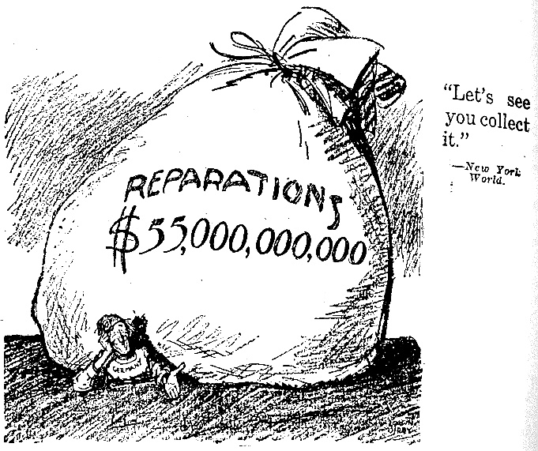
New York World

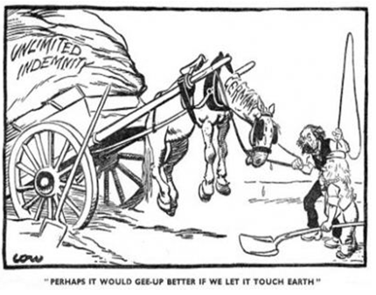
Word Press

Appendix B: Farben Merger, 1925
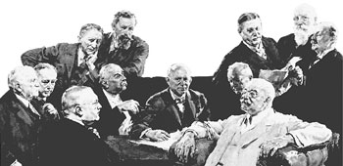
BASF

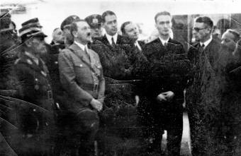
Appendix C: Hitler with Farben officials, Berlin 1936

National Archives

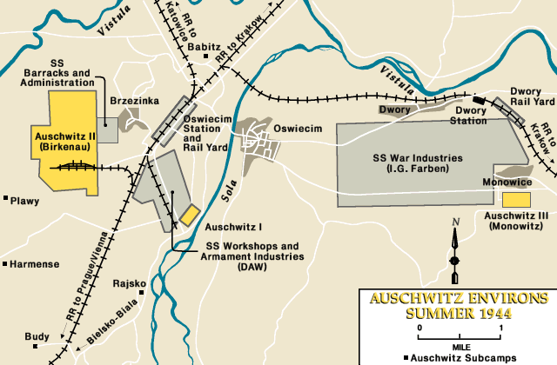
Appendix D: Auschwitz/Monowitz Camp
Word Press

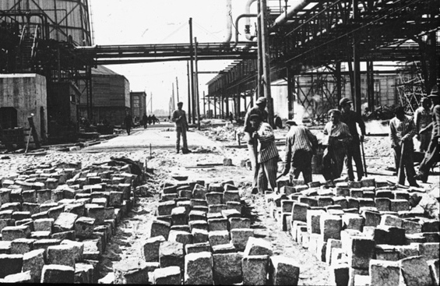
Appendix E: Slave laborers completing Buna/Monowitz, 1942
Holocaust Research Project Organization

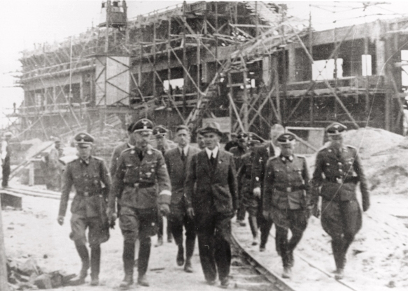

Himmler with Farben engineers,
July 17-18, 1942

U. S. Holocaust Memorial Museum
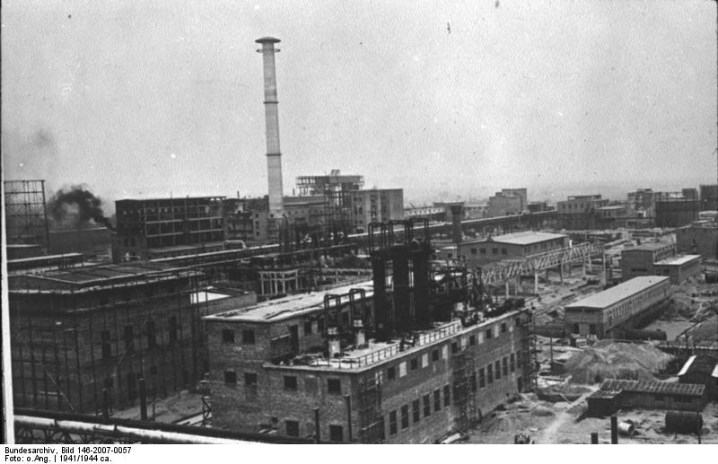
Bundesarchiv

Buna/Monowitz , 1942

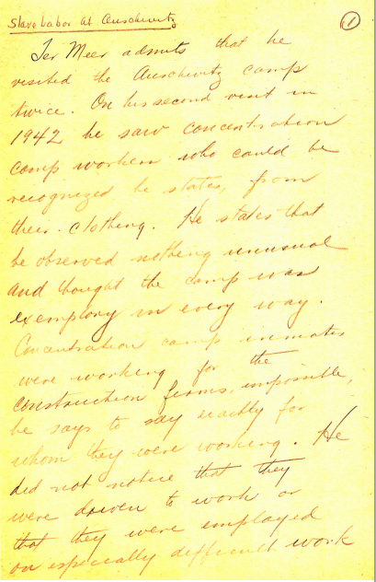
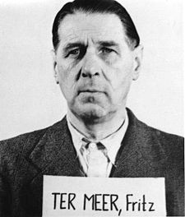
Appendix F: Hebert’s notes on Ter Meer’s testimony

Appendix G: Wollheim and Ormond preparing for trial, 1951
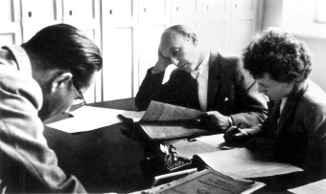

Annotated Bibliography

Primary Sources

Interviews

Brown, Ruth. Interview by Isabel Mermelstein. September 24, 1999. Holocaust Museum
Houston. Oral History Transcript #10-25.

Ruth Brown was a translator at the Nuremberg trials when the leaders of IG Farben were prosecuted for their war crimes. Her comments helped me understand that IG Farben totally denied responsibility for Jewish suffering, instead saying that they were simply following orders from the SS who ran the camps. I used information from this interview to show how the Farben representatives who were on trial placed blame for what happened to the Jews in their forced labor units on the Nazis.

Koppel, Werner. Interview by author. November 14, 2013.

Werner Koppel worked as a slave laborer in IG Farben’s Auschwitz/Monowitz camp. He explained the working conditions in the camp and helped me understand the role that Farben had at that camp. He knew Elie Wiesel, who was also at the camp, and witnessed the hangings and beatings that Wiesel described in his autobiography, Night. He received compensation after Farben agreed to a settlement with Wollheim, but he said a settlement was not enough after what Farben had done to the prisoners who worked for them. I used information from this interview to explain how the slave laborers were treated in Farben’s plant at Auschwitz.
Michel, Ernest. Interview by Matthias Naumann and Stefanie Plappert. July 5, 2007. Wollheim Memorial. http://www.wollheim-memorial.de/en/ernest_w_michel (accessed Nov. 15, 2013).

Ernest Michel is the youngest journalist who covered the Nuremberg Trials and a Holocaust survivor. Although he is in the early stages of Alzheimer’s, he was able to remember interviewing Herman Goering, the most famous prisoner at the trials. He explained that, as a survivor, he wanted to jump across the table and strangle the people who were testifying because they were responsible for killing his parents. He also knew Norbert Wollheim because he worked as a slave laborer in Buna/Monowitz beginning in 1943. He helped me understand how Wollheim got the inspiration for his law suit and why Wollheim felt so strongly about filing suit after the Nuremberg Trials. This interview helped me explain that the light punishments Farben’s executives received made Wollheim want to seek justice in the German civil courts.

Rodell, Fred. Interview by Ronnie Mordan. November 21, 1991. Holocaust Museum
Houston. Oral History Transcript #75.00C.

Fred Rodell was an interpreter at the Nuremberg Trials, witnessing testimony from start to finish. His interview helped me understand that the people from Farben felt no guilt for what they had done, even though Farben furnished all of the Zyklon B gas for the gas chambers and the drugs the Nazis used for medical experiments. I used information from this interview to explain that, in the eyes of the victims, the sentences Farben representatives received were far less than they deserved.

Wollheim, Norbert. Interview by United States Holocaust Memorial Museum. May 10, 1991.
Tapes 1-4, RG-50.030*0257. U. S. Holocaust Memorial Museum, Oral History Archives

I purchased copies of Norbert Wollheim’s interview from the United States Holocaust
Memorial Museum’s oral history archives. This interview includes four tapes and covers Norbert Wollheim early life, including what happened to him during Hitler’s rise to power. He had to quit law school when Jews were no longer allowed to attend German universities; he became a welder to support his family. Since he had organized summer camps for Jewish children, he had experience in transportation, so organizers of the Kindertransport asked him to be in charge of transporting Jewish children ages 12 – 17 to England. Although he was able to help save 7,000 Jewish children through the Kindertransport, he was unable to save his own child, who was two at the time. Later he and his wife and son were arrested and sent to Auschwitz, where he worked in the Farben plant at Auschwitz/Monowitz, but his wife and son were sent directly to the gas chambers. I used information from this interview to talk about Jewish persecution during Hitler’s rise to power, Wollheim’s involvement in the Kindertransport, his arrival at Auschwitz, and his assignment as a slave laborer at Farben’s plant.

Wollheim, Norbert. Interview by United States Holocaust Memorial Museum. May 17, 1991.
Tapes 1-7, RG-50.030*0257. U. S. Holocaust Memorial Museum, Oral History Archives.

These tapes cover Norbert Wollheim’s experiences at the Buna/Monowitz Concentration
Camp, where he worked as a slave laborer from 1943 until his liberation in 1945. He arrived in Buna after I. G. Farben had built the barracks to hold prisoners, and he felt that Farben, itself, was responsible for the decisions that affected his life. After liberation, Wollheim testified at the Nuremberg Trials against Farben and was very disappointed that only five of the defendants involved with the slave labor program received any kind of punishment. He wanted to seek justice, but he had no money, and reparations suits for pain and suffering were not permitted in the German civil courts. After reading a call for creditors that Farben published in the local newspaper, Wollheim got the idea to sue for lost wages, a unique approach that the German courts accepted. I used information from these tapes to talk about the Wollheim vs. Farben lawsuit, the precedent it set in German courts, and the affect that settlement of that suit had on slave laborers from Buna and from other camps, Farben, and other German industries.

Court Transcripts

Georg von Schnitzler, affidavit, March 27, 1947, NI-5197. Fritz Bauer Institute, Subsequent
Nuremberg Trials, Case VI, PDB 2 (e), 67–106.

This is testimony from Georg von Schnitzler about a meeting of leading German industrialists. He explained that during a meeting, Hitler made a speech to persuade the businessmen to fund his political campaign. Hitler’s allied himself with the Volkspartei, pushed for funds and began the relationship with IG Farben at this meeting. I used information from this affidavit to explain Farben’s role in Hitler’s rise to power.
“The IG Farben Trial. The United States of America vs. Carl Krauch.” US Military Tribunal
Nuremberg, Judgment of 30 July 1948. Trials of War Criminals Before the Nuernberg Military Tribunals, Vol. VIII. Library of Congress. http://www.loc.gov/rr/frd/ Military_Law/pdf/NT_war-criminals_Vol-III.pdf (accessed Nov. 13, 2013).

This document is a transcript of the Nuremberg Trials pertaining to IG Farben executive Carl Krauch. The part that was the most helpful was Krauch’s testimony regarding Farben’s slave labor program. It helped me understand that Farben’s defense claimed that it was responsible for production to the Reich and had to hire slave labor to meet the quota. Since that was the case, Farben should not be held responsible for crimes against slave laborers since that was a necessity of the war. I used information from this transcript to explain the defense strategy Farben used to claim its innocence during the Nuremberg Trials.

Paul Macarius Hebert, Slave Labor, Nuremberg Trials Documents (1948). Louisiana State
University Law Center. http://digitalcommons.law.lsu.edu/nuremberg_docs/12 (accessed Dec. 2, 2013).

This is a copy of Nuremberg Trial judge Paul Hebert’s handwritten notes on Fritz ter Meer's testimony before the tribunal. The first and longest section deals with the issue of slave labor at Auschwitz and summarizes ter Meer's two visits to the camp. I used a photo of Hebert’s notes to in my appendix to show

“Slave Labor Policy (Nuremberg 14 Nov. 1945 – 1 Oct. 1946).” Trial of the Major War
Criminals Before the International Military Tribunal. Library of Congress.
www.loc.gov/rr/frd/Military-Law/pdf/NT_VolII.pdf (accessed Oct. 6, 2013).

This document is a transcript of the international military tribunal that pertains to slave labor. It helped me understand Nazi policy on slave labor, including the orders from Nazi authorities such as Himmler, Saukel, and Hitler and the treatment of the laborers. I utilized quotes by Saukel and Himmler, time frames for conscription, numbers of slaves and Article 52 of the Hague Convention. This information helped me explain how the slave labor policies for the Third Reich violated international law.

Trial of the Major War Criminals Before the International Military Tribunal. Nov. 14, 1945 –
Oct. 1, 1946. Library of Congress. http://www.loc.gov/rr/frd/Military_Law/NT_major-
war-criminals.html (accessed Oct. 6, 2013).

This document is testimony about the rearmament of Germany as directed by Hitler. The article discussed how industrialists played a major role in the rearmament program and explained the changes in government and the four year plan. I used this source for background information on how Hitler transformed the government and industries.

Urteil im Wollheim-Prozess [verdict in the Wollheim suit], June 10, 1953. Hessisches
Hauptstaatsarchiv Wiesbaden (=HHStAW), Abt. 460, Nr. 1424 (Wolheim v. IG Farben), vol. III, pp. 444-488. http://www.wollheim-memorial.de/files/1027/original/pdf_Urteil_ im_Wolheim-Prozess_10.06.1953.pdf. (accessed Jan. 20, 2014).

This document is a copy of the verdict issued by the German court concerning Wollheim v. I. G. Farben. Since the verdict is in German, I worked with the German teacher at my high school to translate the verdict into English. It helped me understand some of the testimony in the trial and explained why the court granted Wollheim’s claim in its entirety. I used quotes in the judgment to show on what charges the court found Farben responsible.

Government Documents

“Report to Congress: German Foundation ‘Remembrance, Responsibility, and the Future.’”
Bureau of European and Eurasian Affairs. March 2006. U. S. Department of State http://2001-2009.state.gov/p/eur/rls/rpt/64401.htm (accessed Jan. 15, 2014).

This is a report to U. S. Congress on the background of the Remembrance,
Responsibility, and the Future foundation and the implementation agreement established between the Federal Republic of Germany and the United States to accept reparations payments from German industrial companies and the German government. It had a list of the number of former slave laborers in each country who received payments (over 1.6 million) and the total amount that had been distributed (approximately 5.1 billion dollars). I used this information to describe the foundation established to oversee reparations payments to victims of the Holocaust.

Books

Ferencz, Benjamin B. Less Than Slaves: Jewish Forced Labour and the Quest for
Compensation. Bloomington: Indiana University Press, 1979.

Benjamin B Ferencz, a prosecutor at the Nuremberg Trials, knew Norbert Wollheim and worked with him on his trial. He also worked with the Claims Conference to set up a venue for survivors to receive compensation. This book covers the background for the trial and gives a timeline of events that helped me understand how long the trial took and how evidence from the Nuremberg Trials was used in this case. I used information from this book to explain Norbert Wolheim’s motivation for filing his lawsuit and the German laws that made it difficult for victims to have their cases accepted for trial.

Wiesel, Ellie. Night. New York, Hill and Wang, 1958.

In this autobiography, Ellie Wiesel covers his harrowing experiences from the first whispers of Jewish discrimination to his liberation and physical recovery from the Auschwitz/Monowitz concentration camp. His book helped me understand how Jews were treated in the slave labor camps and why survivors were entitled to compensation. I used quotes from Wiesel’s book and information about the abuses to show how Jews and other prisoners lost all of their rights and why Farben was responsible for what happened to them.
Online Articles

Ferencz, Benjamin B. “Story 50: You Can’t Win Them All.” www.benfrencz.org/index.php?id= 8&zoekterm=wollheim&story=49 (accessed Aug. 9, 2013).

This article describes Ferencz’s law career in New York City, including his work against Farben in the Claims Conference. He explained that many laborers were turned away empty handed and that when Wollheim first sued for $2,500, the Finance Ministry said the matter was between Wollheim and Farben. However, Wollheim’s case established a precedent and settlements for laborers became national law in 2002. I used information from this article to understand the impact of Wollheim’s case and the background on the Claims Conference.

- - - . “West Germany: Supreme Court Bars Claims of Forced Laborers.” June 1967. The
American Journal of Comparative Law, Vol. 15, No. 3, 1967. http://www.benferencz.org/ index.php?id=4&article=24 (accessed Aug. 19, 2013).

This article discussed Dr. Edmund Bartl’s struggle to get redress from Hienkel, the company that had exploited him as a slave laborer during World War II. This article helped me understand the consequences of losing a court case in Germany because Bartl had to pay court fees for both parties after losing the legal battle with Hienkel. Germany delayed the trial, showing no respect for Bartl’s suffering. I used information from this article to explain the obstacles victims faced when they fought for justice in the German courts.

“Claims Conference History.” Claims Conference. www.claimscon.org/forms/CC_AR_
2007.pdf (accessed Aug. 6, 2013).

This document is the Claims Conference 2007 Annual Report with 2008 highlights, which provided me with a summary of the Claims Conference from its Founding through 2007. It explained how the Claims Conference affected settlements for Jews and provided me with background on the deal the Claims Conference brokered with IG Farben after the Wollheim Case. I used information from this document to establish a timeline and to describe the organization used to distribute settlement funds to survivors after Wollheim’s case was settled.

“The Council of Gods.” BASF. http://www.basf.com/group/corporate/en/function/conversions:/ publish/content/about-basf/history/1925-1944/images/Rat-der-Goetter.jpg (accessed March 8, 2014).

This is a photo of the men involved in the BASF merger with five other companies to for
IG Farben. I used this photo in my appendix to show the merger of five chemical companies into one so they would be able to survive the restrictions placed on Germany after World War I.

“Treaty of Versailles, text of Article 231, the ‘War Guilt Clause.’” http://weimar.facinghistory.
org/content/treaty-versaille-text-article-231-war-guilt-clause (accessed Dec. 30, 2013).

This is a copy of the War Guilt Clause which is Article 231 of the Treaty of Versailles. It helped me understand the restrictions placed on Germany after World War I by the Allies. I used it to show why Germany had economic problems and that those problems paved the way for Hitler to take over.
Photos

“Buna/Monowitz, 1942.” Holocaust Research Project Organization. http://www.holocaust researchproject.org/economics/igfarben.html (accessed Jan. 5, 2014).

This is an image of the completed Farben plant at Monowitz. I used it in my appendix to show where Norbert Wollheim worked when he arrived in 1943.

“Himmler Tours Monowitz/Buna.” U.S. Holocaust Memorial Museum. http://digitalassets.
ushmm.org/photoarchives/detail.aspx?id=1036449 (accessed Jan. 15, 2014).

This is a picture of Reichsfuehrer SS Heinrich Himmler touring the Monowitz-Buna
Building site in the company of SS officials and I.G. Farben engineers on July 17-18, 1942. I used this photo in my appendix to show the Farben connection to Nazi leaders during its construction of the new Farben plant at Monowitz.

“Meeting Between Farben and Adolf Hitler.” National Archives. Holocaust Research Project. http://www.holocaustresearchproject.org/economics/igfarbengal/I.G.%20Farben%20board%20member%20Fritz%20ter%20Meer%20(fifth%20from%20right)%20explains%20to%20Adolf%20Hitler%20the%20significance%20of%20synthetic%20rubber,%20Berlin,%201936.html (accessed Jan. 15, 2014).

This is a photo of I.G. Farben board member Fritz ter Meer (fifth from right) in Berline in 1936 explaining to Adolf Hitler the significance of synthetic rubber. I used this photo in my appendix to show the alliance between Adolf Hitler and I.G. Farben.
“Preparation for Trial.” Fritz Bauer Institut. Wollheim Memorial. http://www.wollheim-memorial.de/en/ henry_ormond_19011973 (accessed Jan. 20, 2014).

This is a photo of Henry Ormond (center) during the 1st Frankfurt Auschwitz Trial (1963–1965). I used it in my appendix to show Wollheim preparing for his trial with his attorney.

“Slave Laborers, 1942.” Holocaust Research Project Organization. http://www.holocaust researchproject.org/economics/images/Jewish%20slave%20labor%20at%20the%20IG%20Farben%20plant%20near%20Auschwitz.jpg (accessed Jan. 15, 2014).
This is a picture of slave laborers completing the Buna/Monowitz camp. I used this image in my appendix to show slave labors building the Farben Buna plant.

“Unlimited Indemnity.” http://ashweetha.files.wordpress.com/2012/05/1.jpg (accessed Jan 4, 2014).

This is a political cartoon depicting the massive debt Germany had to overcome as a result of the Treaty of Versailles. I used this image in my appendix to show the impact of the Versailles Treaty on German economy.

Secondary Sources

Books

Jefferys, Diarmund. Hell’s Cartel: IG Farben and the Making of Hitler’s War Machine.
HeinelNew York: Henry Holt and Company, 2008.

This book provides a history IG Farben starting in the early 1920s when company executives were discussing the merger of smaller plants into a conglomerate and ending with Farben’s bankruptcy claim in 2003. The description of IG Farben after the Holocaust gave me valuable information on the interactions between Wollheim and the Claims Conference and re-employment of Farben employees who were former Nazis. I used information from this book to discuss Farben’s recovery from the Nuremberg Trials and its settlement with Wollheim.

Linder, Stephan H. Inside IG Farben: Hoechst During the 3rd Reich. New York: Cambridge
University Press, 2008.

This book provided a detailed account of IG Farben’s history, from its founding to its liquidation. What helped me the most was learning just how much the executives at Farben cooperated with the Nazis. They not only obeyed the Nazi laws, but also became partners with the Nazis in building camps specifically to utilize the slave labor available there. They also furnished the drugs used in medical experiments and felt no remorse for their actions. I used information from this book to explain Farben’s actions following the Nuremberg Trials.

U. S. Holocaust Memorial Museum. Encyclopedia of Camps and Ghettos 1933 – 1945, Vol. 1.
Bloomington: Indiana University Press, 2009.

This book covers the ghettos and concentration camps used by Nazi Germany to isolate and kill Jews during World War II. What helped me was the description of the Buna/Monowitz plant by I.G Farben in Auschwitz. I used information about the trial Norbert Wollheim filed against Farben after the war to get compensation for himself and other slave laborers to show that his case became a “model for subsequent cases against German industry.”

Newspapers

Berger, Joseph. “Norbert Wollheim Dies at 85; Sued Over Forced Nazi Labor.” New York Times,
Nov. 3, 1998. http://www.nytimes.com/1998/11/03/nyregion/norbert-wollheim-dies-at-85-sued-over-forced-nazi-labor.html (accessed Sept. 10, 2013).

This obituary summarized Norbert Wollheim’s life and experiences, including his case against IG Farben and his involvement in the U. S. Holocaust survivor community. This article helped me understand some of the effects of Wollheim’s suit.

Schmale, Oliver. “IG Farben to Make Slave Labor Fund.” Washington Post, August 23, 2000.
http://www.washingtonpost.com/wp-srv/aponline/2000823/aponline220934_000.htm (accessed Sept. 9, 2013).

This newspaper article provided me with a current update of the IG Farben conglomerate, and it included statistics from the Holocaust. I used this article to understand that IG Farben continues to pay 60 years after originally violating the rights of their Jewish laborers.

Online Articles

“Asset Restitution and Indemnification.” U. S. Holocaust Memorial Museum.
http://www.ushmm.org/research/research-in-collections/search-the-collections/ bibliography/asset-restitution-and-indemnification (accessed Jan. 11, 2014).

This article described the different claims against Germany since World War II ended. I
used information from this article to discuss the role of the German chancellor in establishing the Remembrance, Responsibility, and Future foundation.

“Auschwitz: 60 Year Anniversary—the Role of IG Farben-Bayer.” Jan. 27, 2005.
http://www.ahrp.org/infomail/05/01/27a.php (accessed Sept. 17, 2013).

This article included an excerpt of a BBC documentary on an Auschwitz medical experiment survivor who has continued to fight for compensation. Although Wollheim was not a victim of medical experiments, this article helped me understand IG Farben’s blatant disregard for human rights.

“Compensation by Firms from the 1950s to the 1990s.” Wollheim Memorial.
http://www.wollheimmemorial.de/en/ entschaedigung_durch_firmen_von_den_1950er_ bis_in_die_1990er_jahre (accessed Dec. 5, 2013).

This is an article about the impact that Norbert Wollhiem’s suit had on other lawsuits. I used this information to list other successful suits through the 1990s.

“Forced Labor by Jews Under National Socialism.” Wollheim Memorial. http://www.wollheim- memorial.de/en/zwangsarbeit_von_juden_und_juedinnen_im_ns (accessed July 10, 2013).

This article explained how Jews were degraded to little more than animals to further the
war effort in countries taken by Germany. This source helped me understand how the Jews were systematically deported to labor camps and later exterminated through work.

“Forced Labor in German Industry in the Nazi Era.” Wollheim Memorial. http://www.wollheim-memorial.de/en/zwangsarbeit_in_der_deutschen_industrie_waehrend_des_ns (accessed July 10, 2013).

This article explained that as early as 1941, IG Farben could not have succeeded in producing what the government wanted without the use of slave labor. I used information from this source to understand how Farben utilized slave labor to meet its government quotas even though many were exploited until they died of exhaustion. It helped to explain how German companies used laborers to further the German industry.

“German Economy Foundation Initiative.” Wollheim Memorial. http://www.wollheim-memorial.de/en/die_stiftungsinitiative_der_deutschen_wirtschaft_1999 (accessed Jan. 8, 2014).

This article explains the initiative by the German government to settle all of the law suits
against German corporations for their actions during the Nazi era. The suits were causing major problems because some of the German companies were in negotiations with companies in America to merge, and the bad press was influenced their boards to turn down the mergers. To resolve the problems, the German government negotiated a settlement to establish and fund a foundation that would handle reparations claims if the American government would get the courts to drop all law suits against German companies and guarantee that all liability would end once and for all. I used this to explain the motivation for the German government to establish a fund for reparation payments.

Guinnane, Timothy W. “The 1953 London Debt Agreement.” Center Discussion Paper #880,
January 2004. Yale University. http://www.econ.yale.edu/growth_pdf/cdp880.pdf (accessed Dec. 5, 2013).

This paper explains that The 1953 London Debt Agreement was established to avoid the
same problems Germany faced after losing World War I. Since Germany was now divided into two countries, the agreement allowed for the postponement of debt payments until such time that the two countries were united. This helped me understand why some of the German corporations said that they did not have to even consider reparations payments until after Germany reunited. I used this information to discuss why some German firms refused to take part in the reparations process.

Heinelt, Peer. “The Decartelization and Postwar History of I. G. Farbenindustrie AG.” Fritz
Bauer Institute. Goethe Universitat Frankfurt am Main: Norbert Wolheim Memorial, 2011. http://www.wollheim-memorial.de/files/1067/original/pdf_Peer_Heinelt_ The_Decartelization_and_Postwar_History_of_IG_Farbenindustrie_AG.pdf (accessed Aug. 30, 2013).

This article explained that the Allied High Commission Law 35 ordered I. G. Farbenindustrie to dismantle and break up into several smaller companies. It helped me understand that the Allies felt that Farben’s conglomerate, the largest chemical company in the world, had actually helped the Nazis wage World War II by supplying money and materials exclusively for the war effort. I used this information to show that Farben was ordered by the court to dismantle their cartel and to pay reparations for slave labor.

- - -. enc“Financial Compensation for Nazi Forced Laborers.” Norbert Wollheim Memorial.
J.W. Goethe-Universitat/Fritz Bauer Institut. Frankfurt am Main, 2010. http://www.wollheimmemorial.de/files/1066/original/pdf_Peer_Heinelt_Financial_Compensation_for_Nazi_Forced_Laborers.pdf (accessed Dec. 5, 2013).

This article discussed the history of forced labor compensation after World War II and helped me understand that settlement payments were linked to legal pressure, never true remorse for crimes against humanity. I used information from this article to discuss Farben’s attitude that the company would not admit responsibility toward survivors if it agreed to pay compensation. .

“Nazi Forced Labor: History, Legal Framework, and Structures.” Wollheim Memorial. Accessed
http://www.wollheim-memorial.de/en/nszwangsarbeit_geschichte_gesetzliche_ rahmenbedingungen_und_strukturen (accessed Aug. 10, 2013).

This article discussed how Nazi Germany started forced worker programs as early as 1938. As other countries became part of the Reich, Nazis stripped the rights from people in conquered countries and put them in forced labor details to help the Nazi War effort. Over 1.7 million people were part of the forced labor program; only half survived the war. This article helped me understand how many people were used in the forced labor programs and that the companies that used slave labor paid the Nazis a small fee to use them. I used information from this article to understand the forced labor program.

“Norbert Wollheim’s Involvement in Organizing the Kindertransporte.” Wollheim Memorial.
http://www.wollheim-memorial.de/en/norbert_wollheims_beteiligung_an_der_ organisation_der_kindertransporte (accessed Dec. 31, 2013).

This article described Wollheim’s role in rescuing six to seven thousand children from an unspeakable fate in Germany. His involvement in the Kindertransporte marked him as an influential player in the Holocaust early on. Although I do not focus on the Kindertransporte, I felt it was important to mention Wollheim’s involvement to show that he was a man of principle who took responsibility for saving the lives of Jewish children.

“’Recruitment’ For Forced Labor.” Wollheim Memorial.
Error! Hyperlink reference not valid. (accessed June 10, 2013).

This article provided a description of the “recruitment” methods utilized by the Nazi Party to fill the necessary quota of forced laborers. These processes differed depending on the country that “volunteers” were obtained from. This article helped me understand that the recruiters bribed workers from friendly countries, but forcible conscription was used against those unsympathetic to Nazi ideals. This article helped me understand how the German Reich abused civilian rights by forcing them into slave labor.

“Restitution and Compensation.” AJR Information (Association of Jewish Refugees in Great
Britain). May 1956. Vol. 6, No. 5. http://www.ajr.org.uk/journalpdf/1956_may.pdf
(accessed Dec. 20, 2013).

This is a British publication targeting Jewish refugees, which speaks about post Holocaust retribution and activities in the Jewish community. This article helped me understand that IG Farben liquidator, Dr. Walter Schmidt, represented Farben in Norbert Wollheim’s agreement for settlement. This article helped me understand the impact Wollheim’s case had on the Jewish community.

Ramasastry, Anita. Corporate Complicity: From Nuremberg to Rangoon – An Examination of
Forced Labor Cases and Their Impact on the Liability of Multinational Corporations, 20 Berkely J. Int’l Law. 91 (2002) http://scholarship.law.berkely.edu/bjil/vol20/iss1/4 (accessed Sept. 22, 2013).

This article examined the impact of post-World War II war crimes tribunals and civil lawsuits filed by forced laborers seeking settlements for their service to German companies. This article helped me understand the effects of the unprecedented trials and litigations.

Rumpf, Joachim. “Norbert Wollheim’s Lawsuit Against I.G. Farbenindustrie AG i.L.” Fritz
Bauer Institute. Goethe Universitat Frankfurt am Main: Norbert Wollheim Memorial,
2010. http://www.wollheim-memorial.de/files/1059/original/pdf_Joachim_Rumpf_ Norbert_Wollheims_Lawsuit_against_IG_Farbenindustrie_AG_iL.pdf. (Aug. 30, 2013).

This article gave information about the tactics German courts used to avoid responsibility for reparations claims by former IG Farben slave laborers. It helped me understand that survivors faced difficult obstacles when seeking redress for their persecution during World War II. I used information from this source to explain how Norbert Wollheim devised a plan to see redress in a unique way so the German courts would accept his lawsuit.

Spoerer, Mark. “Forced Labor in The Third Reich.” Norbert Wollheim Memorial. J.W. Goethe-
Universitat- Fritz Bauer Institut. Frankfurt am Main, 2010. http://www.wollheim-memorial.de/files/1065/original/pdf_Mark_Spoerer_Forced_Labor_in_the_Third_Reich.pdf (accessed Oct. 13, 2013).

This article explained the multiple methods Nazis used for recruitment and described the living conditions and labor deployment. This source gave me a basic understanding of the process of enslaving the masses needed to power the German war machine.

Stengel, Katharina. “Competition for Scant Funds: Jewish, Polish, and Communist Prisoners of
Auschwitz in the Negotiations for the Wollheim Agreement.” http://www.wollheim-memorial.de/files/1064/original/pdf_Katharina_Stengel_Competition_for_Scant_Funds_Jewish_Polish_and_Communist_Prisoners_of_Auschwitz_in_the_Negotiations_for_the_Wollheim_Agreement.pdf (accessed Aug. 29, 2013).

This article explained that Wollheim’s case set a precedent in German courts. To protect itself from further lawsuits, Farben agreed to settle, if it could do so without claiming responsibility for its actions. It helped me understand why Farben settled and that it used the Claims Conference to pay the compensation. I used information from this article to explain that Wollheim was the first concentration camp inmate to receive the right to damages from a private corporation. His surprising victory caused great concern among the other large firms because they feared the lawsuits that this precedent might bring.

Weinke, Annette. “Background of the Judicial Process of ‘Coming to Terms with the
Buna/Monowitz Concentration Camp; Possibilities, Problems, and Limits.” http://www.wollheimmemorial.de/files/1056/original/pdf_Annette_Weinke_Background_of_the_Judicial_Process_of_Coming_to_Terms_with_the_BunaMonowitz_Concentration_Camp_Possibilities_Problems_and_Limits.pdf (accessed Sept. 15, 2013).

This article explained that Wollheim’s case was a test case to establish a precedent for compensation. It helped me understand that the Federal Republic was the new government in Germany and to avoid law suits by former slave laborers, officials chose to view forced labor as war-related and necessary, not enslavement. I used information from this article to explain the background behind the Wollheim case, the defense used by Farben in the trial, and Farben’s rationale for settling the case rather than letting the courts determine its punishment.

“Wollheim v. IG Farben.” Wollheim Memorial.
http://www.wollheim-memorial.de/en/das_
verfahren_wollheim_gegen_ig_farben (accessed June 10, 2013).

This article summarizes the Wollheim v. IG Farben court case and the subsequent negotiations between Farben and the Claims Conference. IG Farben “donated” 27 million marks to the Claims Conference for Jewish Compensation. This source helped me understand the basic approach Wollheim’s attorney used and the impact that the judgment had on forcing IG Farben to take responsibility for its actions.

Zuppi, Alberto L. “Slave Labor in Nuremberg’s I.G. Farben Case: The Lonely Voice of Paul M.
Hebert, 66 LA. L. Rev. (2006). http://digitalcommons.law.lsu.edu/lalrev/vol66/iss2/5 (accessed Oct. 1, 2013).

This source revealed the impact of Wollheim’s case. After fighting for reparations and paving the way for an agreement between IG Farben and the Claims Conference, Wollheim’s case forced Germany to recognize the need for a compensation agreement. I used information from this article to explain the events leading up to the foundation created under German law to distribute reparations to survivors.

Photos

“Auschwitz Environs.” http://geographicalimaginations.files.wordpress.com/2013/04/ auc42030.gif (accessed March 17, 2014).

This Auschwitz Concentration Camp area map shows where I.G. Farben located its plant. I used this photo in my appendix to show that Farben located Buna/Monowitz next to the Nazi concentration camp so it could utilize slave labor in the factory.

Benjamin B. Ferencz, Less Than Slaves: Jewish Forced Labour and the Quest for Compensation. (Bloomington: Indiana University Press, 1979), 33-68; Urteil im Wollheim-Prozess [verdict in the Wollheim suit], June 10, 1953. Hessisches Hauptstaatsarchiv Wiesbaden (=HHStAW), Abt. 460, Nr. 1424 (Wollheim v. IG Farben), vol. III, pp. 444-488. [Translated by J. Joslin]. http://www.wollheim-memorial. de/files/1027/original/pdf_ Urteil_ im_WolheimProzess_10.06. 1953.pdf (accessed Jan. 20, 2014).
“Treaty of Versailles, text of Article 231, the ‘War Guilt Clause.’” http://weimar.facinghistory .org/ content/treaty-versaille-text-article-231-war-guilt-clause (accessed Dec. 30, 2013).
Norbert Wollheim, interview by United States Holocaust Memorial Museum. May 10, 1991. Tapes 1-4, RG-50.030*0257. U. S. Holocaust Memorial Museum, Oral History Archives.
Stephan H. Lindner, Inside IG Farben. (New York: Cambridge University Press, 2008), 1.
Georg von Schnitzler, affidavit, March 27, 1947, NI-5197. Fritz Bauer Institute, Subsequent Nuremberg Trials, Case VI, PDB 2 (e), 67–106.
Wollheim, May 10, 1991 interview; “Norbert Wollheim’s Involvement in Organizing the Kindertransporte.” Wollheim Memorial. http://www.wollheim-memorial.de/en/norbert_wollheims_beteiligung_ an_der_ organisation_der_kindertransporte (accessed Dec. 31, 2013).
Diarmuid Jeffreys, Hell’s Cartel: IG Farben and the Making of Hitler’s War Machine. (New York: Metropolitan Books, 2008), 143-173.
The IG Farben Trial. The United States of America vs. Carl Krauch et al. US Military Tribunal Nuremberg, Judgment of 30 July 1948. Trials of War Criminals Before the Nuernberg Military Tribunals, Vol. VIII. Library of Congress. http://www.loc.gov/rr/frd/ Military_Law/pdf/NT_war-criminals_Vol-III.pdf (accessed Nov. 13, 2013).
Alberto L. Zuppi, “Slave Labor in Nuremberg’s I. G. Farben Case: The Lonely Voice of Paul M. Hebert.” Louisiana Law Review, Volume 66, Number 2, Winter 2006. http://digitalcommons.law.lsu.edu/lalrev/ vol66/iss2/5 (accessed Oct. 1, 201); Elie Wiesel, Night. (New York: Hill and Wang, 2006), 49; Farben Trial, 245; “Slave Labor Policy (Nuremberg 14 Nov. 1945 – 1 Oct. 1946).” Trial of the Major War Criminals Before the International Military Tribunal. Library of Congress. www.loc.gov/rr/frd/Military-Law/pdf/NT_VolII.pdf (accessed Oct. 6, 2013); “Forced Labor in German Industry in the Nazi Era.” Wollheim Memorial. http://www.wollheim-memorial.de/en/zwangsarbeit_in_der_deutschen_industrie_waehrend_ des_ns (accessed July 10, 2013).
Norbert Wollheim, interview by United States Holocaust Memorial Museum. May 17, 1991. Tapes 1-7, RG-50.030*0257. United States Holocaust Memorial Museum, Oral History Archives. .
Farben Trial, 5; Peer Heinelt, “The Decartelization and Postwar History of I. G. Farbenindustrie AG.” Fritz Bauer Institute. Goethe Universitat Frankfurt am Main: Norbert Wolheim Memorial, 2011. http://www.wollheim-memorial.de/files/1067/original/pdf_Peer_Heinelt_The_Decartelization_and_ Postwar_History_of_ IG_Farbenindustrie_AG.pdf (accessed August 30, 2013); Ferencz, Less Than Slaves, 34-37.
Fred Rodell, interview by Ronnie Mordan. November 21, 1991. Holocaust Museum Houston. Oral History Transcript #75.00C; Wollheim, interview May 17, 1991; Paul Macarius Hebert,” Slave Labor,” Nuremberg Trials Documents (1948). Louisiana State University Law Center. http://digitalcommons. law.lsu.edu/nuremberg_docs/12 (accessed Dec. 2, 2013).
Joachim Rumpf, “Norbert Wollheim’s Lawsuit Against I.G. Farbenindustrie AG i.L.” Fritz Bauer Institute/Goethe Universitat Frankfurt am Main: Norbert Wollheim Memorial, 2010. http://www.wollheim-memorial.de/files/1059/original/pdf_Joachim_Rumpf_Norbert_Wollheims_Lawsuit_against_IG_Farbenindustrie_AG_iL.pdf. (August 30, 2013); Ernest Michel, interview by Matthias Naumann and Stefanie Plappert. July 5, 2007. Wollheim Memorial. http://www.wollheim-memorial.de/en/ernest_w_michel (accessed Nov. 15, 2013).
Ben Ferencz, “West Germany: Supreme Court Bars Claims of Forced Laborers.” June 1967. The American Journal of Comparative Law, Vol. 15, No. 3, 1967. http://www.benferencz.org/index.php?id= 4&article=24 (accessed Aug. 19, 2013); Annette Weinke, “Background of the Judicial Process of ‘Coming to Terms with the Buna/Monowitz Concentration Camp; Possibilities, Problems, and Limits.” http://www.wollheimmemorial.de/files/1056/original/pdf_Annette_Weinke_Background_of_the_Judicial_Process_of_Coming_to_Terms_with_the_BunaMonowitz_Concentration_Camp_Possibilities_Problems_and_Limits.pdf (accessed Sept. 15, 2013); Ruth Brown, interview by Isabel Mermelstein. September 24, 1999. Holocaust Museum Houston. Oral History Transcript #10-25; Wollheim, May 17, 1991 interview.
Wollheim, May 17, 1991interview; Wiesel, 49.
Urteil im Wollheim-Prozess [verdict in the Wollheim suit].
“Wollheim v. IG Farben.” Wollheim Memorial. http://www.wollheim-memorial.de/en/das_ verfahren_wollheim_gegen_ig_farben (accessed June 10, 2013).
Ferencz, Less Than Slaves, 37-39; Katharina Stengel, “Competition for Scant Funds: Jewish, Polish, and Communist Prisoners of Auschwitz in the Negotiations for the Wollheim Agreement.” http://www.wollheim-memorial.de/files/1064/original/pdf_Katharina_Stengel_Competition_for_Scant_Funds_Jewish_Polish_and_Communist_Prisoners_of_Auschwitz_in_the_Negotiations_for_the_Wollheim_Agreement.pdf (accessed Aug. 29, 2013).
Ferencz, Less Than Slaves, 50; “Claims Conference History.” Claims Conference. www.claimscon.org/forms/ CC_AR_2007.pdf (accessed Aug. 6, 2013).
Guinnane, Timothy W. “The 1953 London Debt Agreement.” Center Discussion Paper #880, January 2004. Yale University. http://www.econ.yale.edu/growth_pdf/cdp880.pdf (accessed Dec. 5, 2013); “Compensation by Firms from the 1950s to the 1990s.” Wollheim Memorial. http://www.wollheimmemorial.de/en/ entschaedigung_durch_firmen_von_den_1950er_bis_in_die_1990er_jahre (accessed Dec. 5, 2013); “Asset Restitution and Indemnification.” U. S. Holocaust Memorial Museum. http://www.ushmm.org/research/research-in-collections/search-the-collections/ bibliography/asset-restitution-and-indemnification (accessed Jan. 11, 2014).
Pier Heinelt, “Financial Compensation for Nazi Forced Laborers.” Norbert Wollheim Memorial. J.W. Goethe-Universitat/Fritz Bauer Institut. Frankfurt am Main, 2010. http://www.wollheimmemorial.de/files/ 1066/original/pdf_Peer_Heinelt_Financial_Compensation_for_Nazi_Forced_Laborers.pdf (accessed Dec. 5, 2013); U. S. Holocaust Memorial Museum. Encyclopedia of Camps and Ghettos 1933 – 1945, Vol. 1. (Bloomington: Indiana University Press, 2009), 218; “Compensation by Firms.”
“German Economy Foundation Initiative.” Wollheim Memorial. http://www.wollheim memorial.de/en/die_stiftungsinitiative_der_deutschen_wirtschaft_1999 (accessed Jan. 8, 2014).
Heinelt, “Financial Compensation;” Werner Koppel, interview by author. Nov. 14, 2013; “Report to Congress: German Foundation ‘Remembrance, Responsibility, and the Future.’” Bureau of European and Eurasian Affairs. March 2006. U. S. Department of State. http://2001-2009.state.gov/p/eur/rls/rpt/64401.htm (accessed Jan. 15, 2014).

